

**Secure Software Development**

Year 2 (2021/22), Semester 3

**SCHOOL OF INFOCOMM TECHNOLOGY**

Diploma in Cybersecurity & Digital Forensics

**Assignment**

**Secure Web Application**

**Duration:** Weeks 8 - 15

**Weightage:** 40%

**Individual/Team/Both:** Both

**Deadline: 1 Aug 2020, 11:59pm (Sunday)**

|  |  |
| --- | --- |
| **Group Name** | **Team 6** |
| **Student IDs** | **S10204829, S10204529, S10203318** |
| **Student Names** | **Neo Rei Siang Edward, Sng Wei Liang Jeremy, Ben Aw Yong Keen Weng** |
| **Module Group** | **CSF03** |

Table of Contents

1. Introduction 9

1.1 Project Title, Vision and Description 9

1.2 Members and Features 9

1.3 3-Tier Application Architecture 9

2. Authentication 10

2.1 Secure Software Requirements 10

2.1.1 Use Cases and Misuse Case Modelling 11

2.1.2 Data Classification 12

2.1.3 Subject/Object Matrix 14

2.2 Secure Software Design 15

2.2.1 Authentication Related Security Design 16

2.2.2 Attack Surface Evaluation 17

2.2.2.1 Entry Points 17

2.2.2.2 Exit Points 18

2.2.3 Threat Modelling 19

2.2.3.1 Attack Trees 19

2.2.3.2 STRIDE 20

2.2.3.3 DREAD 21

2.3 Secure Software Coding 22

2.3.1 Authentication Related Defensive Coding Practices 22

2.3.1.1 Input Validation 22

2.3.1.2 Input Sanitization 23

2.3.1.3 Error Handling 24

2.3.2 Secure Software Processes 25

2.3.2.1 Versioning 25

2.3.2.2 Code Analysis 25

2.3.2.3 Code/Peer Review 25

2.4 Secure Software Testing 26

2.4.1 Test Strategy 26

2.4.2 Test Plan 27

2.4.3 Test Cases 28

2.5 Security Conclusion of Feature 31

3. Authorization 31

3.1 Secure Software Requirements 31

3.1.1 Data Classification 32

3.1.2 Subject-Object Matrix 34

3.1.3 Use Cases 35

3.1.4 Misuse Cases 38

3.2 Secure Software Design 42

3.2.1 Features of Secure Software Design 42

3.2.2 Attack Surface Evaluation 43

3.2.2.1 Entry points 43

3.2.2.2 Exit points 43

3.2.3 Threat Modelling 45

3.2.3.1 Attack Trees 45

3.2.3.2 STRIDE 50

3.2.3.3 DREADi 53

3.3 Secure Software Coding 55

3.3.1 Features of Secure Software Coding 55

3.3.1.1 Input Validation 55

3.3.1.2 Input Sanitization 56

3.3.1.3 Error Handling 56

3.3.1.4 Proper Role Management 57

3.3.2 Secure Software Processes 57

3.3.2.1 Versioning 57

3.3.2.2 Code Analysis 58

3.3.2.3 Code/Peer Review 58

3.4 Secure Software Testing 59

3.4.1 Test Strategy 59

3.4.2 Test Plan 60

3.4.3 Test Cases 61

3.5 Security Conclusion of the Feature 62

4. CRUD Database 63

4.1 Secure Software Requirements 63

4.1.1 Use Cases and Misuse Case modeling 63

4.1.2 Data Labelling and Classification 65

4.1.3 Subject/Object Matrix 68

4.2 Secure Software Design 70

4.2.1 CRUD Database related security design 71

4.2.2 Attack Surface Evaluation 71

4.2.2.1 Entry Points 71

4.2.2.2 Exit Points 73

4.2.3 Threat Modeling 75

4.2.3.1 Attack Tree 75

4.2.3.2 STRIDE 76

4.2.3.3 DREAD ranking 78

4.3 Secure Software Coding 79

4.3.1 CRUD database related defensive coding practices 79

4.3.1.1 Input Validation 79

4.3.1.2 Input Sanitisation 81

4.3.1.3 Error Handling 82

4.3.2 Secure Software Processes 83

4.3.2.1 Versioning 83

4.3.2.2 Code Analysis 84

4.3.2.3 Code/Peer Review 84

4.4 Secure Software Testing 85

4.4.1 Test Strategy 85

4.4.2 Test Plan 85

4.4.3 Test Cases 86

4.5 Security Conclusion of the CRUD Database 87

5. Miscellaneous Pages 88

5.1 Book Store Page 88

5.1.1 Book Store Page Display 88

5.1.2 Book Store Page Code 91

5.1.2.1 Book Object Class 91

5.1.2.2 Book Object Class Input Validation 91

5.1.2.3 Book Store Code 92

5.2 Cart Page 94

5.2.1 Cart Page Display 94

5.2.2 Cart Page Code 96

5.2.2.1 Cart Code 96

5.3 Payment Page 96

5.3.1 Payment Page Display 96

5.3.2 Payment Page Code 98

5.3.2.1 Payment Page Class 98

5.3.2.2 Payment Page Class Input Validation 98

5.3.2.3 Payment Page code 99

5.3.2.4 Payment Successful Page code 99

5.4 Feedback Form 99

5.4.1 Feedback Form Display 99

5.4.2 Feedback Form Code 100

5.4.2.1 Feedback Object Class 100

5.4.2.2 Feedback Object Validation 101

5.4.2.3 Feedback Form Page 101

5.4.2.4 Feedback Thank You Page 101

6 Advanced Authentication Features 102

6.1 Email Confirmation and Forgot Password Email 102

6.2 QR CodeMulti-factor Authentication 104

6.3 External Login 105

6.3.1 Google External Login 105

6.3.2 Facebook External Login 106

6.3.3 Microsoft External login 107

7. Conclusion 107

8 References 109

8.1 Authentication References 109

8.2 Authorization References 110

8.3 CRUD Database References 111

8.4 Code References 112

9. Appendix 114

9.1 CheckList Of Authentication 114

9.2 CheckList of Authorization 115

9.3 CheckList of CRUD Database 116

9.4 CheckList of Code 118

9.5 Code Used For Miscellaneous Pages 119

9.5.1 Code For Book Pages 119

9.5.1.1 Code Used For Book Pages 119

9.5.1.2 Code Used For Checking Authorization 119

9.5.1.3 Code Used For Searchstring And Drop Down List 120

9.5.1.4 Code Used To Display Error Message When 0 books Are In The Database 120

9.5.1.5 Code Used For Displaying Book Items 121

9.5.1.6 Code used For Displaying Last Row Contents 122

9.5.2 Code Used For Cart page 123

9.5.2.1 Code Used for Displaying Cart Page 123

9.5.3 Code Used For Payment page 126

9.5.3.1 Code Used For Payment Class 126

9.5.3.2 Code Used Displaying Payment Page 127

9.5.3.3 Code For Displaying Thank You Page 127

9.5.4 Code Used For Feedback page 128

9.5.4.1 Code Used For Feedback Class 128

9.5.4.2 Code Used For Displaying Feedback Form Page 128

# 1. Introduction

## 1.1 Project Title, Vision and Description

The title of our website project is EZ-Books.

With this project, we wanted to create an e-commerce website for customers to use to purchase e-books online. For the project, we have created a secured website that allows users to browse through book items, order book items and to provide feedback for the website to improve.

## 1.2 Members and Features

For the mandatory requirements, Jeremy did Authentication, Edward did Authorization, and Ben did CRUD Database and Audit. For the Miscellaneous Pages, Edward did the Books index page, Books Details Page, Payment Page, and Feedback Page. Ben did the About Us Page and the Cart Page. Jeremy did external logins as an additional feature.

## 1.3 3-Tier Application Architecture

The website created is holistically secure as all three parts, software, hosts, and network are secured. An application needs to be holistically secure so as to prevent attackers from exploiting the applications. In order to make the software secure, secure software features such as input validation, input sanitization, and error and exception handling were used in the software. To make hosts secure, auditing and logging were done so as to track each action made by each user on the application. Roles were also used to set up authorization within the website to set aside permissions so that attackers have limited access to the website's functions. To make a network secure, authentication has been used to authenticate users’ identity. Data transferred over the network is also encrypted and safe.

# 2. Authentication

Authentication is a security management feature that validates the claimed identity of an entity (users). Common methods of authentication include Anonymous, Basic, Digest, Integrated, Client certificates, Forms, Token, Smart Cards, and Biometrics. Multi-Factor Authentication incorporates multiple factors to authenticate the user’s claims and improves overall security standards to authentication.

# 2.1 Secure Software Requirements

As stated previously, Authentication is the validation of an entity’s claim as the legitimate entity. Entities range from can take the form of a person, process or a hardware device. Authentication occurs when an entity presents itself as the legitimate user through providing personal credentials and is verified via a trusted source that has stored the credentials. Typically, in a website, these sources are often SQL Databases.

In terms of the web application, the authentication method used is Form Authentication. Form Authentication requires username and password inputs from the user for authentication purposes. These credentials are validated against the back-end database.

As the credentials come in clear text form, the data should be protected during transmission in addition with Transport Layer Security (TLS) such as Secure Sockets Layer (SSL) or network layer security such as IPSec.

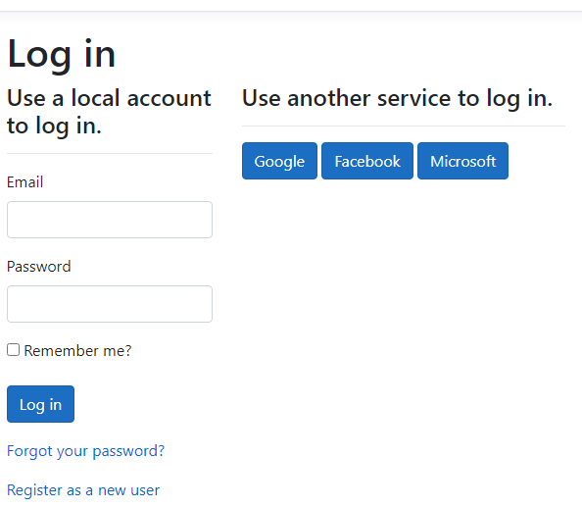

Figure 2.1a Forms Authentication

## 2.1.1 Use Cases and Misuse Case Modelling

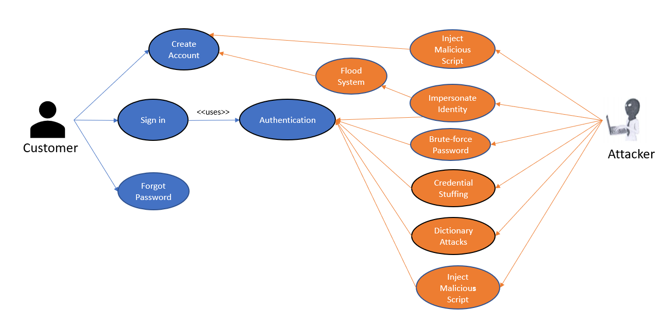

Figure 2.1.1.1: Use Case & Misuse Case Modelling

Use case modelling is the practice of determining how users interact and perform tasks on the software application features. Organizations use case modelling to determine software functionality and security requirements that have been put in by predicting how users will interact with the features as well as how the software will respond to user inputs.

In terms of Authentication, the model shows how a customer would interact with the application. The customer has 3 possible actions, The first action is “Account Creation” via the registration feature where the user is required to input an email address and password. Next, the user is able to sign-in into the web application by inputting his account credentials (email and password) to use the other services. However, before the user is given permission to access resources, the credentials are first verified with the back-end database which holds the user’s credentials. Lastly, the user is able to change their password through the “Forget Password” feature, this is a security feature that allows the user to perform countermeasures if their password were compromised.

Similar to use case modelling, misuse case modelling is the process of determining negative scenarios that can happen by accident or intentionally. An example of an intentional attempt is how an attacker would try to exploit the software application features.

These negative scenarios are unintended behaviour of the system that the owner is trying to prevent when users are performing the use cases. Organizations use misuse case modelling to gain insight into certain threats and vulnerabilities in their application as well as putting themselves in the attacker’s shoes. Hence, allowing the organization to implement Defensive coding features such as Input Sanitization to prevent the misuse cases from occurring.

## 2.1.2 Data Classification

Data labelling is the classification of informational assets via the level of sensitivity in the form of labels. These classifications are based on the potential impact of the Confidentiality, Integrity, Availability (CIA) upon disclosure, alteration or destruction.

|  |  |  |  |
| --- | --- | --- | --- |
| Data | Impact on Confidentiality | Impact on  ntegrity | Impact on  Availability |
| User’s Emails | High | High | High |
| User’s Passwords | High | High | High |
| User’s Full Name | High | High | High |

Three data points have been identified for the Authentication Classification. The first data is the user’s email address. The impact on Confidentiality, Integrity and Availability is high for all. The user’s email address should never be leaked as it is the user’s personal information. Furthermore, leaked email addresses can be used for malicious intent by Attackers by sending Phishing or Pharming emails. Moreover, the user’s email may be used for other important purposes outside of the organization’s web application and disclosure or alteration to the email may cause severe consequences for both the user and organization.

The next data identified is the User’s Passwords. Similar to the user’s email address, the impact on confidentiality, integrity and availability is high. The reason for this, is that the user’s password is considered personal information and should be well protected. A follow up to the previous data point, in the scenario where the attacker is able to know the user’s email and password, he will be granted access to the users account and is able to cause serious consequences. Furthermore, the user may link their password to other important devices or services. The attacker may try to do credential stuffing on all other platforms and can gain unauthorized access to the user’s personal information such as their mobile devices, email accounts or credit card details. Hence, many web services perform hashing on their users passwords so that in-case their database was attacked and the passwords were leaked, the passwords will still be protected until the password is cracked.

Lastly, the user’s full name is the last data identified. The impact on confidentiality, integrity and Availability is high. The data should be protected as the user’s full name is the user’s personal information. Unlike the previous two data identified, the impact on the user’s full name is medium as although the user’s name is often shared publicly between friends, family, clients or organization, the user’s name should not be shared to people they do not know. Furthermore, the attack could stalk the user's personal information from their name and can target close family members, friends or even the user themselves with personalised phishing attacks.

In Conclusion, all data points in the data classification for authentication all need to be protected and cannot be leaked as the data is the user’s personal information.

## 2.1.3 Subject/Object Matrix

A Subject-Object Matrix is a two-dimensional matrix and is used to identify allowable permissions between subjects (roles) and objects (components) based on use cases. The inversing of these allowable actions in the Subject-Object matrix can give insight to

the existence of threats, hence assisting in determining security requirements.

|  |  |  |  |
| --- | --- | --- | --- |
|  | Subjects | | |
| Objects | Customer | Admins | Website |
| Website | Create Email Info  ------------------------------  Create Password Info  ------------------------------  Create Full Name Info | Create Email Info  Read Email Info  Update Email Info  Delete Email Info  -----------------------------------  Create Password Info  Read Email Info  Update Email Info  Delete Email Info  -----------------------------------  Create Full Name Info  Read Full Name Info  Update Full Name Info  Delete Full Name info | -----------------------------------  ----------------------------------- |
| Database |  |  | Store Email Info  Store Password info  Store Full Name Info |

# 2.2 Secure Software Design

Secure Software Design is the approach of incorporating security throughout the development lifecycle so that the software will have little to no vulnerabilities and exploits. This helps make the system as resilient to attacks as possible. Furthermore, time spent on determining and fixing security flaws is lessened in the future since security features were previously set in place.

## 2.2.1 Authentication Related Security Design

One secure software design principle used for Authentication is Password Hashing.

Hashing is the processing of the password input of any length by the user through a hash function to produce a unique array of numbers and letters, otherwise known as a hash value. Hashing provides data integrity as the hash cannot be reversed to obtain the plaintext as well as making sure the contents of the password are not changed by unauthorized users.

Another security software design used for authentication is the implementation of Multi-Factor Authentication. Multi-Factor Authentication is the use of more than one factor to authenticate an identity, this provides a heightened security. Examples of authentication methods include Tokens, Smart Cards, and Biometrics.

In the web application, we incorporated Mobile One-Time Pin (OTP) tokens after the users have entered their usernames and passwords to sign in, the users would have to access their mobile authenticator and enter a pin that has a 30 second lifecycle. If the pin is not entered within the stipulated time, the authenticator will create a new pin for the user to enter.

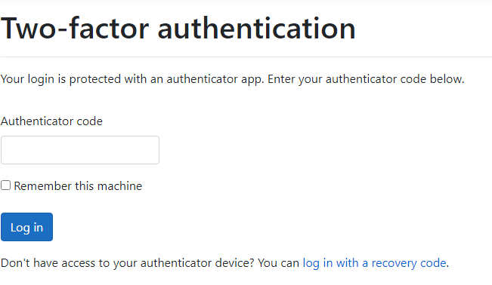

Figure 2.2.1.1 : showing Multi-factor authentication

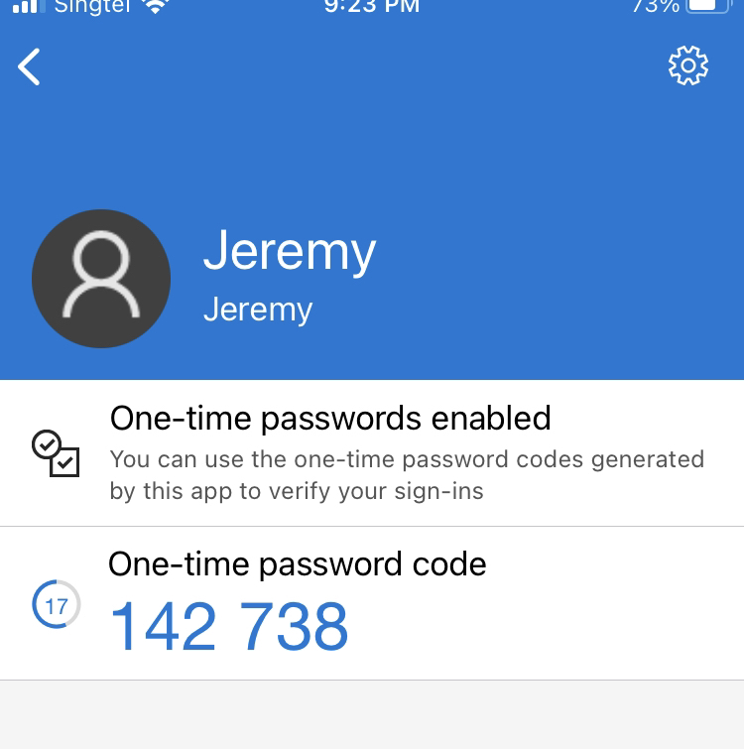

Figure 2.2.1.2 : Mobile Authenticator OTP

## 2.2.2 Attack Surface Evaluation

### 2.2.2.1 Entry Points

Entry points are features in a website that can take a user's input. Each entry point is a potential threat source that attacks can use to attack the database or users by sending malicious scripts or codes.

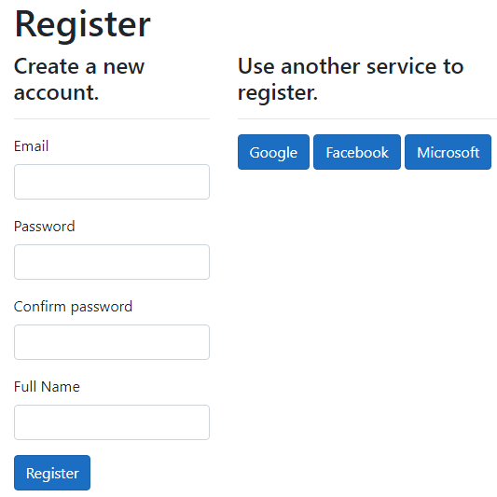

Figure 2.2.2.1.1 : Registration Page

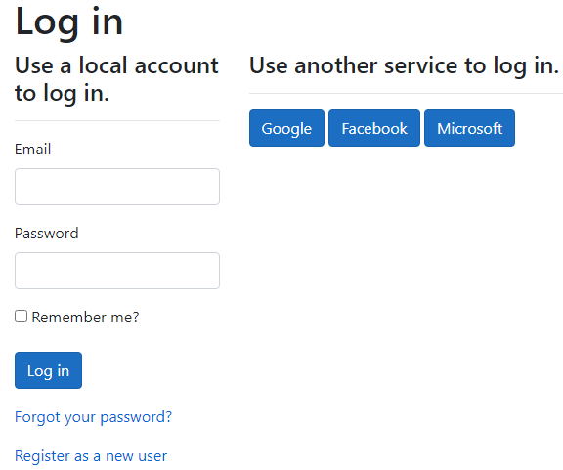

Figure 2.2.2.1.2 Login Page

In Authentication, There are two pages that the attacker can interact with, they are the Registration page and Login Page.

### 2.2.2.2 Exit Points

Exit Points are items that display information from within the system. Exit points can be the source of information leakage and need to be protected. For authentication, There is no proper exit points. However, The registration and login page both have error messages in place of exit points that display information from the database to prevent leakage.

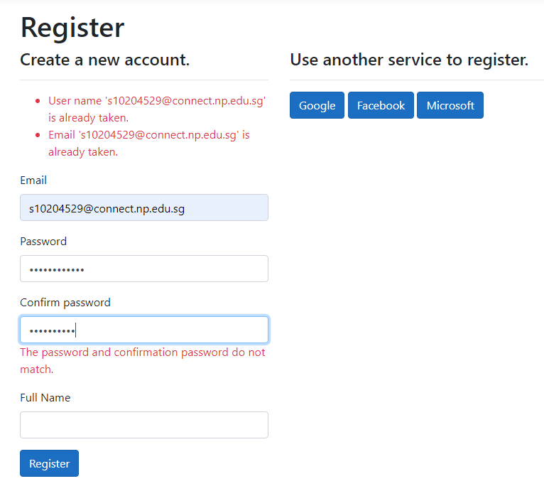

Figure 2.2.2.2.1 : Registration Page error messages

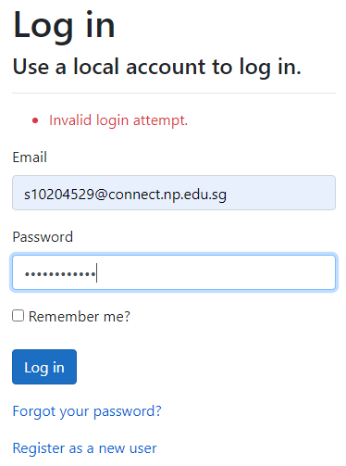

Figure 2.2.2.2.2 Login Page error message

## 2.2.3 Threat Modelling

Threat Modelling is a systematic, iterative and structured security technique during software development. It provides the attacker’s point of view and identifies vulnerabilities in the Entry and Exit points.

### 2.2.3.1 Attack Trees

Attack trees are conceptual diagrams that show how the application feature might be attacked. The Root nodes represent the attacker’s intention while the leaf nodes represent subgoals necessary to reach the goal.

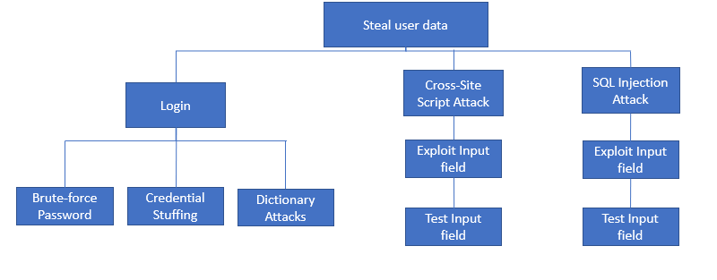

Figure 2.2.3.1.1 : Attack Tree - Steal user data

One objective (root node) the attack might want to achieve is to steal user data. There are three methods (sub goals) to achieve the objective. The first method is through Logging in to the user’s account without their authorization. To do that, The attacker can either brute-force their passwords, do credential stuffings, use dictionary attacks or even reflected cross-site scripting attack.

Another method is through Cross-Site Scripting (XSS) Attacks. The attacker would first have to test the input fields to ensure that there is no input validation or sanitization. Next, he would exploit the entry point by executing a malicious script to gain access to the user’s account.

Lastly, the attacker could send a SQL Injection attack. SQL Injection uses Structured Query Language (SQL) commands to interact with the database to output data. Similar to XSS, the attacker will first test the input fields to see if input validation or data sanitization is implemented in the entry point. Next, he would run test commands to gain insight on how to launch the injection attack. Once he has exploited the input field, the attacker would run a sql command to exploit the database and make it output the customers personal data such as their credit card information.

### 2.2.3.2 STRIDE

STRIDE is an acronym for categorical threat list and is used in threat modelling as the objectives of the attacker are taken into consideration. STRIDE stands for Spoofing (S), Tampering (T), Repudiation (R), Information Disclosure (I), Denial of Service (D) and Elevation of Privilege (E).

|  |  |  |
| --- | --- | --- |
|  | Goal | Identified Threat |
| S | Spoofing | Session Hijacking  Cross Site Scripting |
| T | Tampering | SQL Injection Attack  Eavesdropping  Cookie Replay |
| R | Repudiation | Account Deletion |
| I | Information Disclosure | Information Leakage (User/Website)  Cookie Replay |
| D | Denial of Service | Application-Layer Flooding |
| E | Elevation of Privilege | Logic Flaws  Impersonation of Admin |

### 2.2.3.3 DREAD

DREAD is a security risk assessment model that assesses threats. DREAD stands for Damage(D), Reproduction(R), Exploitability (E), Affected users (A) and Discoverability (D). Damage refers to the quantifiable ranking of how much damage the exploited vulnerability causes. Reproduction is whether the threat is easily recreatable. Exploitability refers to the amount of effort for the creation of the vulnerability. Affected users is the amount of users affected by the vulnerability. Lastly, Discoverability refers to the difficulty of discovering the vulnerability.

[Reference for scoring](https://wiki.openstack.org/wiki/Security/OSSA-Metrics#DREAD) (OStack Development Team, n.d.)

|  |  |  |  |  |  |  |
| --- | --- | --- | --- | --- | --- | --- |
| Threat | D | R | E | A | DI | Average Rank |
| Session Hijacking | 2 | 2 | 2 | 1 | 3 | 2.0 (Medium) |
| Cross-Site Scripting Attack | 3 | 3 | 3 | 3 | 3 | 3.0 (High) |
| SQL Injection | 3 | 3 | 2 | 3 | 2 | 2.6 (High) |
| Eavesdropping | 2 | 1 | 2 | 3 | 2 | 2.0 (Medium) |
| Cookie Replay | 3 | 2 | 2 | 1 | 2 | 2.0 (Medium) |
| Account Deletion | 2 | 2 | 3 | 1 | 2 | 2.0 (Medium) |
| Information Leakage (User) | 3 | 3 | 2 | 2 | 2 | 2.4 (High) |
| Information Leakage  (Website) | 3 | 1 | 2 | 3 | 2 | 2.2 (High) |
| Application Layer Flooding | 3 | 2 | 3 | 3 | 3 | 2.8 (High) |
| Logic Flaws | 1 | 1 | 1 | 2 | 1 | 1.2 (Low) |
| Impersonation of Admin | 3 | 2 | 2 | 3 | 3 | 2.6 (High) |

# 2.3 Secure Software Coding

## 2.3.1 Authentication Related Defensive Coding Practices

### 2.3.1.1 Input Validation

Input Validation refers to the process of verifying that input data entered by users into the entry point is of the correct data type and formatting as well as falling within expected and allowed range of values. Furthermore, input validation stops inputs from being interpreted as code and does not masquerade in alternate forms that bypass security controls. For Authentication features, there are multiple entry points. In Startup.cs For the Registration feature, we modified the password settings configuration to require the password to have at least 1 digit, alphanumeric, unique, uppercase and lowercase character and cannot be left empty. Furthermore, the length is set to minimum 6 and maximum 100 in the Register.cs. Moreover, the use of Model validation through MVC() helps validate inputs as the inputs are checked client side before being posted to the server.

Another Input Validation is using the model validation. An example is the [EmailAddress] Attribute as it requires a valid email address

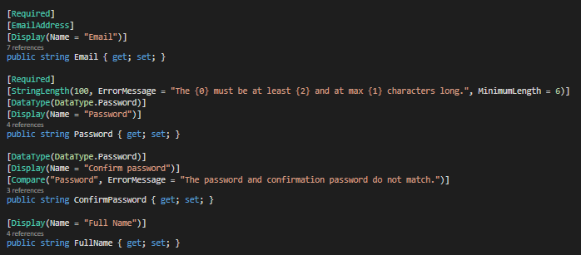

Figure 2.3.1.1.1 : Register.cshtml.cs model validation

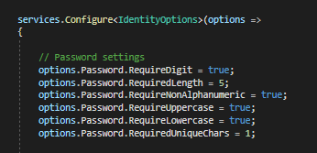

Figure 2.3.1.1.2 : Startup.cs password validation

Similar to the Registration feature, the Login feature also requires a valid email address.

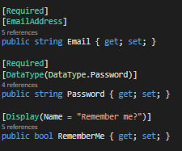

Figure 2.3.1.1.3 : Login.cshtml.cs model validation

### 2.3.1.2 Input Sanitization

Input Sanitization is the process of transforming the data that is supplied by the user before it is processed by the website. For Sanitization, the Full Name entry point in the registration page uses Literalization. Literalization treats the user input in its most literal form, thus not treating the input as a script or query. In the example, I made a test account with the Full Name <script>Alert(“XSS”)</script>

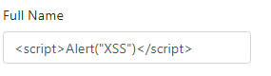

Figure 2.3.1.2.1 : Script attempt on full name in Registration page.

However, upon registration of the account, the script is not run and is kept in its most literal form of a plaintext.

### 2.3.1.3 Error Handling

For Error Handling, the registration and input fields, empting the click the submit button with empty fields would result in an error. Instead of showing sensitive information in the error such as the code path, we added error messages to not only protect the information from being disclosed but also to be more user friendly so they can understand their errors.

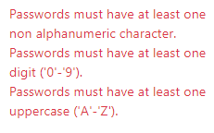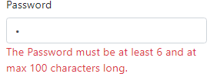

Figure 2.3.1.3.1 : Registration Password error messages

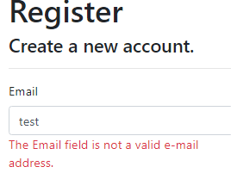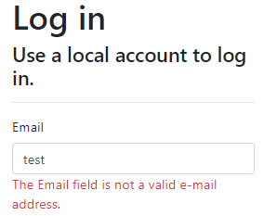

Figure 2.3.1.3.2 Login and Registration page email error message.

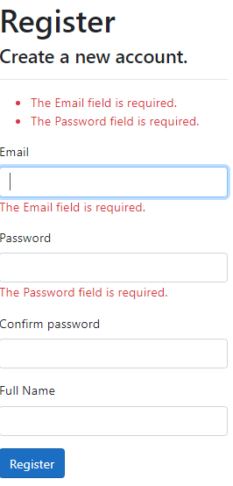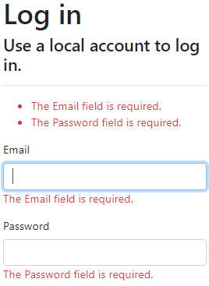

Figure 2.3.1.3.3 Login and Registration page Null email error message.

## 2.3.2 Secure Software Processes

### 2.3.2.1 Versioning

The software version used by every member in the group was the same as its important when pushing/pulling code. These packages were installed, including AntiXss Version 4.3.0,

Microsoft.AspNetCore.Authentication.Facebook Version 3.1.15,

Microsoft.AspNetCore.Authentication.Google Version 3.1.15,

Microsoft.AspNetCore.Authentication.MicrosoftAccount Version 3.1.15,

Microsoft.AspNetCore.Identity.EntityFrameworkCore Version 3.1.15,

Microsoft.AspNetCore.Identity.UI Version 3.1.15, Microsoft.EntityFrameworkCore.SqlServer Version 3.1.15, Microsoft.EntityFrameworkCore.Tools Version 3.1.15, Microsoft.VisualStudio.Web.CodeGeneration.Design Version 3.1.15 and SendGrid Version 9.24.1.

### 2.3.2.2 Code Analysis

Visual Studios 2019 was used for Code Analysis. Visual Studios 2019 provides static code analysis and gives helpful errors and warning messages when building the Authentication factors. An example is how an error message would pop up and stop the process if certain packages or lines of code had errors in them.

### 2.3.2.3 Code/Peer Review

Everyone in the group contributed equally in the implementation of the web application. Every member conducted tests and gave reviews to each other’s code when implementing a feature to test that the feature was working as intended. Furthermore, suggestions for improvements on each other’s code were given to help improve overall quality of the web application.

OWASP ZAP, a security tool that can be used to check how secure a software is, was also used to check how secure the website created was.

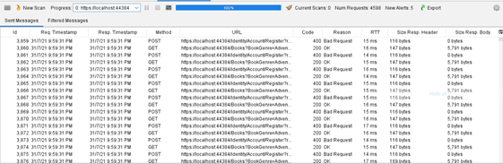

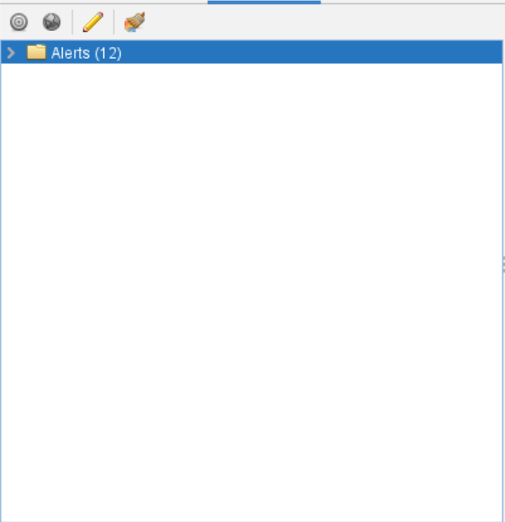

From the screenshots, the website seemed to be quite secure as out of 4598 processes scanned, only 12 alerts were flagged from the tool. Hence, the website is quite secure.

# 2.4 Secure Software Testing

Secure Software Testing is the testing of features from an attacker’s perspective to validate if the software is able to withstand the attack as well as uncover new vulnerabilities. Tests for input validation and sanitization, injection flaws, scripting attack controls, error and exception handling, external email confirmation, external login features and multi factor authentication.

## 2.4.1 Test Strategy

To ensure that the Authentication features were working as intended. We first had to have at least 1 email address we have access to and is readily available as well as our mobile phones with Microsoft Authenticator app and QR code scanner installed. The goal of this is to test the email confirmation feature sent an email to the registered email as well as testing the forget password feature. Furthermore, we needed to test the Multi-Factor Authentication feature to see if we are able to scan the qr code to register the mobile devices as an authenticator as well as testing the One Time Pin input from the Authenticator.

## 2.4.2 Test Plan

|  |  |  |
| --- | --- | --- |
| Test Requirements | Test Methods | Test Coverage |
| Validate Registration input fields. | Check if malicious characters can be used  Check if Scripts can be executed  Check if null inputs can be submitted  Check if data inputted is in the correct format and is within parameters. | Ensures that the entry points in the Account Registration page are secure and have parameters set in place and are working as intended |
| Validate Login input fields | Check if malicious characters can be used  Check if Scripts can be executed  Check if null inputs can be submitted  Check if data inputted is in the correct format and is within parameters.  Check if RequiredConfirmedEmail parameter is working | Ensures that the entry points in the Login page are secure and have parameters set in place and are working as intended  Ensures RequiredConfirmedEmail parameter is working as intended |
| Email Confirmation | Check if Email is sent to registered email address  Check if users are able to login into the web application with an unconfirmed account. | Ensures that the SendGrid SendMail function is working as intended as well as the confirmation link is working.  Ensures that User Accounts require a verified email to mitigate spoofing attacks. |
| Forgot Password | Check if Email is sent to the registered email address  Check if users can type unregistered emails in the input field  Check if Users are able to enter a new password | This ensures that the SendGrid SendMail function as well as the link is working as intended  Ensures that no error messages will appear if unregistered email is entered  Ensures that password settings configurations still work with the forgot password page. |
| External Login Feature | Check if unverified emails can be used to register for an account  Test if email is registered after configuring External Login  Check if the Registered Account through external login immediately signs the user in.  Check if User can register with a email already linked to an account  Test if registered account via external Login signs user in without confirmed email | Ensures that the feature is working as intended  Ensures that email still needs to be confirmed when logging in via external login feature. |
| Test Multi-factor Authenticator | Check if QR code works to  register mobile device as a authenticator  Check if Code works to register mobile device as a authenticator  Checks if Authenticated accounts require One-Time Pin before accessing their account | Ensures that the Multi-Factor Authenticator is working with the Login Page as intended |
| Test Lockout feature | Check if the user is able to login into account after the user is locked out. | Ensures Account Lockout Feature is working as intended |

## 2.4.3 Test Cases

|  |  |  |  |  |
| --- | --- | --- | --- | --- |
| ID | Requirement Specification | Testing Approach | Expected Result | Verdict |
| 1 | Entry Points (input fields) | Test out malicious characters such as “<>’;:\-.”  Test script codes such as  <script>alert(“Hello”)</script>  Test Null Inputs  Test out breaking email formats or using all small characters with a password size of 200 | Error Message ”The Email field is not a valid e-mail address.”  Scripts do not run even if it fits formatting  Error Message “The Email field is required.  The Password field is required.”  Error Message “The Password must be at least 6 and at max 100 characters long”  Error Message “Passwords must have at least one non alphanumeric character.”  “Passwords must have at least one digit ('0'-'9').”  “Passwords must have at least one uppercase ('A'-'Z').”  “Passwords must have at least one uppercase ('a'-'z').” | Success |
| 2 | Entry Points (input fields) | Test out malicious characters such as “<>’;:\-.”  Test Wrong Password  Test null inputs | Error Message  “invalid login attempt.”  Error Message”The Email field is required.”  “The Password field is required.” | Success |
| 3 | SendGrid Function  Valid Email Address | Check Valid email if message has been sent  Click Confirm Account Link | Message is delivered to the registered email  Link Works | Success |
| 4 | Entry Points (input fields)  SendGrid Function | Check Valid Email if message has been sent  Click Forgot password Link  Test input field with fake email  Test input field with unallowed password  Login with new password | Message is delivered to registered email  Link works  No Error message is given when submitted  Error Message “The Password must be at least 6 and at max 100 characters long”  Error Message “Passwords must have at least one non alphanumeric character.”  “Passwords must have at least one digit ('0'-'9').”  “Passwords must have at least one uppercase ('A'-'Z').”  “Passwords must have at least one uppercase ('a'-'z').”  New Password works | Success |
| 5 | External Login Function  Entry Points (input fields) | Use unverified email to login to external login service  Enter Email to create account  Test if External login logs in user  Register with a pre-registered email  Test Sign in feature with and without confirmed email | Only Verified email is able to get External Login to work  Account created  Clicking External Login immediately logs in user  Error Message “Username is already taken.”  “Email is already taken.”  Unconfirmed:  User is unable to Login and has to create a new account  Confirmed:  User is immediately signed in | Success |
| 6 | Mobile Phone  QR Code Scanner  Microsoft Authenticator Installed | Try to Authenticate using QR Code  Try to Authenticate with Code  Test One-Time Pin (correct and incorrect) | Phone is registered after scanning QR Code  Phone is registered after entering code  (incorrect)  User is not sign in, has to enter code again  (correct)  User is signed in | Success |
| 7 | Registered Account | Login after Entering wrong credentials 10 times and get locked out | User is redirected to Lockout Page  Error Message “This account has been locked out, please try again later.”  Unable to log back in | Success |

# 2.5 Security Conclusion of Feature

In Conclusion, Authentication is vital in order to have a secure web application. It creates restrictions on any entry point and is needed throughout the development lifecycle. When used correctly, Authentication can prevent severe threats from occurring. Examples of these threats include SQL Injection and Cross-Site Scripting as these attacks exploit the input fields. Furthermore, Authentication can come in many forms, ranging from tokens, emails, passwords, or even biometrics. Although Authentication is crucial, it needs to be incorporated with other features such as Authorization and the CRUD Database to truly make a web application holistically secure.

# 3. Authorization

Authorization is a security management feature that determines what resources a person can have access to. Authorization is used to categorise multiple groups of users into “Roles” that can have special permissions when accessing resources. Some “Roles” will have less permissions than others (TheEconomicTimes, 2021). This is done so as to control the access levels of individuals to prevent attackers from gaining access to confidential documents or information, making the website more secure.

# 3.1 Secure Software Requirements

A secure software is a software that must be reliable, where it functions as it is expected to. The software must be resilient, which means that it does not violate any security policy and is able to withstand actions of threat agents. Lastly, the software needs to have recoverability so as to restore operations to normal by containing, limiting and remediating the damage caused by the threats. Many requirements are needed to make a software secure, but this section of the report will be covering the Authorization requirement.

Companies use a Role-Based Access Control (RBAC) to fulfill authorization requirements. In a RBAC, individuals have access to a resource based on their assigned role. Roles such as Admin and Users can be created. Permissions such as Create, Read, Update or Delete are also assigned, deleted and determined through the RBAC. With these roles created, users are assigned to these roles, which allow them to have access to certain resources.

## 3.1.1 Data Classification

Data Classification is assigning labels to data. These labels are a level of sensitivity that is based on the potential impact the data can have to Confidentiality, Integrity, and availability upon disclosure, alteration or destruction.

|  |  |  |  |
| --- | --- | --- | --- |
| Data | Impact of Loss of Confidentiality | Impact of Loss of Integrity | Impact of Loss of Availability |
| Roles’ Names | High | High | High |
| Accounts Associated to a Role | High | High | High |
| Role’s Description | Low | Low | Low |
| User’s Emails | High | High | High |

For the Authorization feature, four potential data has been identified. The first data is the name of the roles. The name of the roles should not be leaked out because it shows the number of roles in the website as well as the names of all the roles stored in the database. In the event, the attacker can modify his account to have a role that matches with the database, he would be able to access non-authorised pages. Therefore, the name of the roles should be kept confidential. The name of the roles cannot be changed as well because the name of the roles in the database must match the name of the role specified in the code to be given access to administrative pages. Thus if the name of the role is changed, the name of the roles in the database will change accordingly and the users associated with the changed role will not be able to have the given access, making integrity very important. The availability of the role names are also important because administrators use these role names to facilitate proper access control between the different roles of users. If these role names are not available, all users would have equal rights, which can lead to disastrous outcomes.

The second data is the accounts that are associated with each role. The accounts cannot be leaked as it shows which accounts belong to which roles. This gives information to the hackers on which accounts to target to gain administrative privileges, which results in Confidentiality having a high priority. Attackers should also not be able to modify the accounts’ role. If attackers are able to modify the roles, they can either delete all the roles created, making users not accessible to some features of the website, or can move all accounts to be under the administrative roles, making everyone have administrative power. The accounts should also always be available for administrators to manage as there are accounts that are always being created and these accounts may belong to different roles. Administrators need to keep watch and ensure that none of the accounts are moved to a different role without consent.

The third data is the description of each role. The description of the role does not have high impacts on Confidentiality, Integrity and Availability. This is because even if the information is leaked out to the attackers, modified by the attackers, or cannot be accessed by the administrators, it does not have much impact on the website as a whole. However, input validation is still needed for these areas because in an event an attacker gains administrative privileges, he is able to type in these fields and can launch attacks such as cross-site scripting or sql injection that can affect the whole system.

The fourth data is the user’s emails. User’s emails should not be leaked out to the attackers as this can result in loss of personal information. Furthermore, attackers can use these emails for phishing attacks, which can result in unfavourable outcomes. The emails should also not be modified by attackers. Since the emails are the ones that link an account to a specific role, if the email is changed, the account will no longer be associated with the role and the account will not have the same access to certain pages. Users’ email must be available to administrators as administrators need the emails to send out important notifications and updates to users.

## 3.1.2 Subject-Object Matrix

A subject-object matrix is a two-dimensional representation of roles and objects in the website. Subject-Object Matrix is used to identify allowable actions such as create, read, update, and delete between roles and objects based on use cases. Companies can use the subject-object matrix to determine the existence of threats by inversing the allowable actions identified in the matrix. Thus, the subject-object matrix can be used to determine security requirements.

|  |  |  |  |  |  |
| --- | --- | --- | --- | --- | --- |
| Objects | Admin | BookAdmin | FeedbackAdmin | AuditAdmin | Customer (No Role) |
| About Us  Page  -----------------  Books Page  -----------------  Cart Items Page  -----------------  Payment Page  -----------------  Feedback Form  -----------------Audit Page  -----------------  Roles Page | Read Items  Update Items  -----------------------------  Read Book Items  Create Book Items  Update Book Items  Delete Book Items  -----------------------------  Create Cart Items  -----------------------------  Create Payment Items  Read Payment Items  -----------------------------  Read Feedback Items  Create Feedback Items  Delete Feedback Items  -----------------------------  Read Audit Items  Create Audit Items  Update Audit Items  Delete Audit Items  -----------------------------  Read Roles Items  Create Roles Items  Update Roles Items  Delete Roles Items | Read Items  --------------------------  Read Book Items  Create Book Items  Update Book Items  Delete Book Items  --------------------------  Create Cart Items  --------------------------  Create Payment Items  --------------------------  Create Feedback Items  --------------------------  -------------------------- | Read items  ------------------------  Read Book Items  ------------------------  Create Cart Items  ------------------------  Create Payment Items  ------------------------  Read Feedback Items  Create Feedback Items  Delete  Feedback Items  ------------------------  ------------------------ | Read items  -------------------------  Read Book Items  -------------------------  Create Cart Items  -------------------------  Create Payment Items  -------------------------  Create Feedback Items  --------------------------  Read Audit Items  Create Audit Items  Update Audit Items  Delete Audit Items  ------------------------- | Read items  --------------  Read Book Items  --------------  Create Cart Items  --------------  Create Payment Items  --------------  Create Feedback Items  --------------  -------------- |

From the Subject-Object Matrix, a total of seven objects and five possible roles are in the website. The role, “Admin”, is the most powerful role as it has access to every page and is the role that is accountable for creating other roles. “FeedbackAdmin”, “BookAdmin”, “AuditAdmin” roles are similar in power as each role administers a page of the website. “Customer” or no role has the least power because they only have the ability to do certain actions.

These roles are separated as such so as to have a more secure website, as well as to ensure that there is proper separation of duties between the roles. Due to the separation of roles, if an attacker gets access to any one of the administrative accounts, they will not be able to access the whole website, unless the attackers managed to get a hold of an “Admin” account. Thus, this makes the website more secure as the roles still have limits to how much an attacker can access to.

## 3.1.3 Use Cases

Use case modelling is a mechanism used by companies to determine software functionality and security requirements. Companies put themselves in the positions of a customer and identify what customers can do such as signing in and creating an account. From these use cases, misuse cases are developed.

For the Authorization feature, there are a total of five use cases. The first use case revolves around the perspective of a customer. A customer has the ability to do four actions. The first is to Log in to an account or register an account. The second is the ability to read the items in the bookstore. Next, a customer has the ability to order these items from the bookstore and can make payments for them. Lastly, a customer can create a feedback item in the Feedback Form.

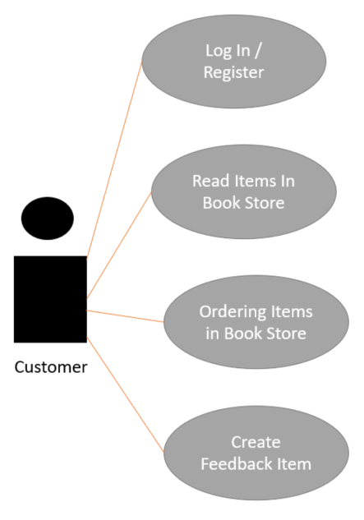

Figure 3.1.3.1 : Use Case For Customer

Moving on, the second case revolves around the perspective of an account with the role, “BookAdmin”. These accounts can do the same actions as a customer, but can also create book items, update book items and delete book items. These accounts will be used for managing the items in the bookstore.

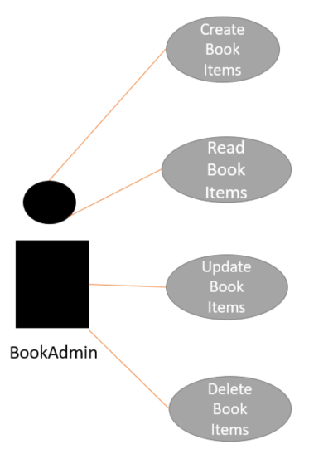

Figure 3.1.3.2: Use Case For BookAdmin

The next case revolves around the perspective of an account with the role, “FeedbackAdmin”. Similar to the second case, accounts associated with this role can do the same actions as a customer, but can also read feedback items, and delete feedback items. Accounts associated with this role will be used for managing the feedback form.

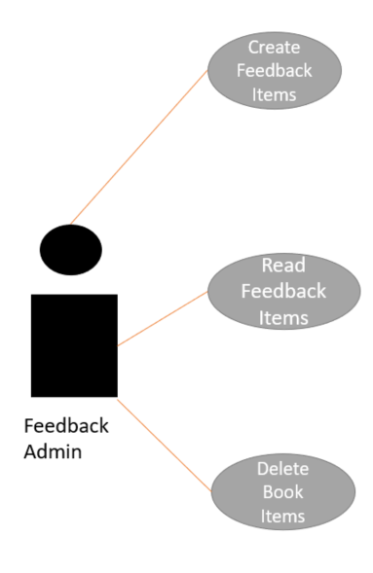

Figure 3.1.3.3: Use Case For FeedbackAdmin

For the fourth case, it will revolve around the perspective of an account with the role, “AuditAdmin”. Likewise to the second and third case, the accounts assigned to this role have the ability to do the same actions as a customer, but can also create audit items, read audit items, update audit items, and delete audit items. Accounts assigned to this role will mainly be used for managing the audit pages.

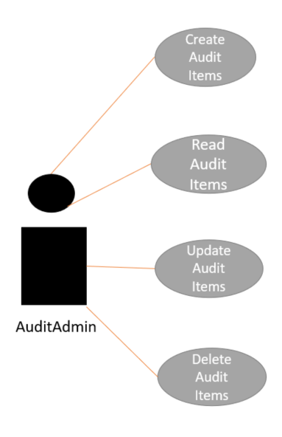

Figure 3.1.3.4: Use Case For AuditAdmin

Lastly, the fifth case revolves around the perspective of an account with the role, “Admin”. Accounts associated with this role have the most power as they have access to all pages, including pages used for assigning and managing the roles. These accounts will mainly be used for the managing, creating, and deleting of roles.

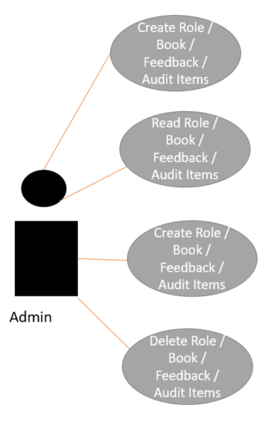

Figure 3.1.3.5: Use Case For Admin

## 3.1.4 Misuse Cases

Misuse cases help identify security requirements by using the use cases to develop negative scenarios such as impersonating customers’ identity and stealing customers’ credit card information. Thus, misuse cases are intentional or accidental scenarios that can happen to the website, which provides companies insight into the potential threats that can occur against the system or software.

For all misuse cases created, all creating and updating of items will have input fields that can have the “Buffer Overflow Attack”, “Cross-Site Scripting Attack”, and “SQL Injection Attack” attack threats.

For the first Misuse case, logging in and registering an account, there are input fields and thus have the same threats as mentioned above. Other than those three threats, the other threats are related to stealing account credentials and the methods that could be taken. For the reading of the book items, attackers can be trying to access admin-only pages on the bookstore page. For the ordering of book items, there are input fields and thus it has the three attack threats mentioned above. Furthermore, there is also the threat that the attacker can steal payment credentials and impersonate users and purchase items without the original user content. Lastly, creating a feedback item has two threats, which is basically impersonating a user and creating many feedback items, and also for the attacker to try to access admin only pages on the feedback form.

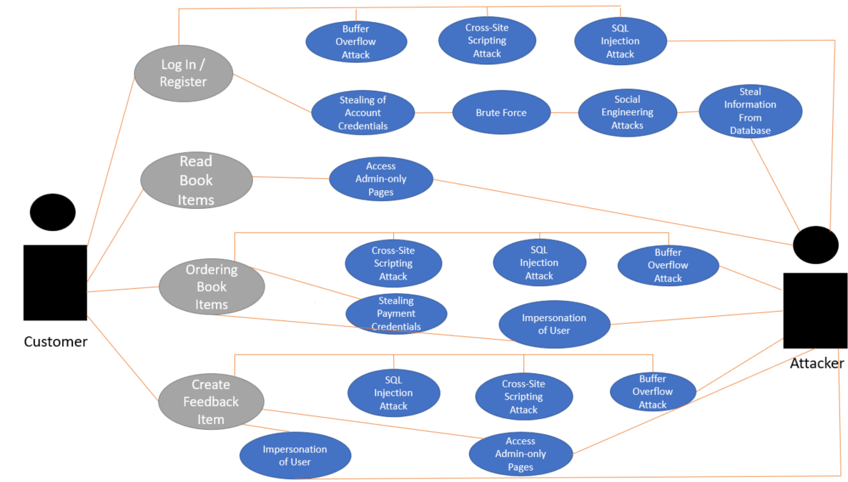

Figure 3.1.4.1: Misuse Case For Customer

For the second Misuse case, creation of book items can create errors to crash the website. For the reading of book items, no attack threats were found. For the updating of the book items, attackers can update the books to create errors to crash the website or to make the website unpresentable to customers. Lastly, deleting the book items can cause data loss and make the website unpresentable.

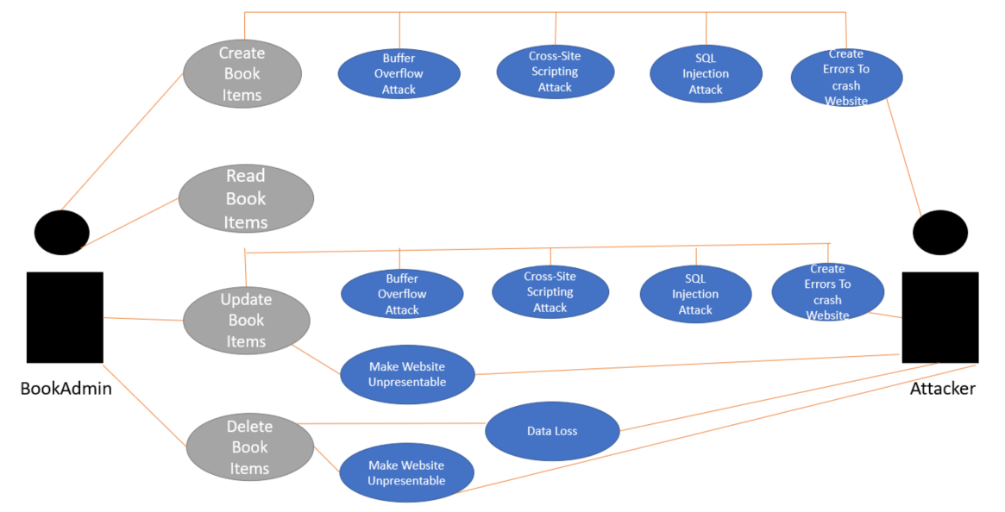

Figure 3.1.4.2: Misuse Case For BookAdmin

For the third Misuse case, feedback items are not accessible to the public and thus attackers can try to gain access to the items to steal information and identify possible errors other users can face to exploit it. Lastly, deleting book items can result in data loss and making the website unpresentable.

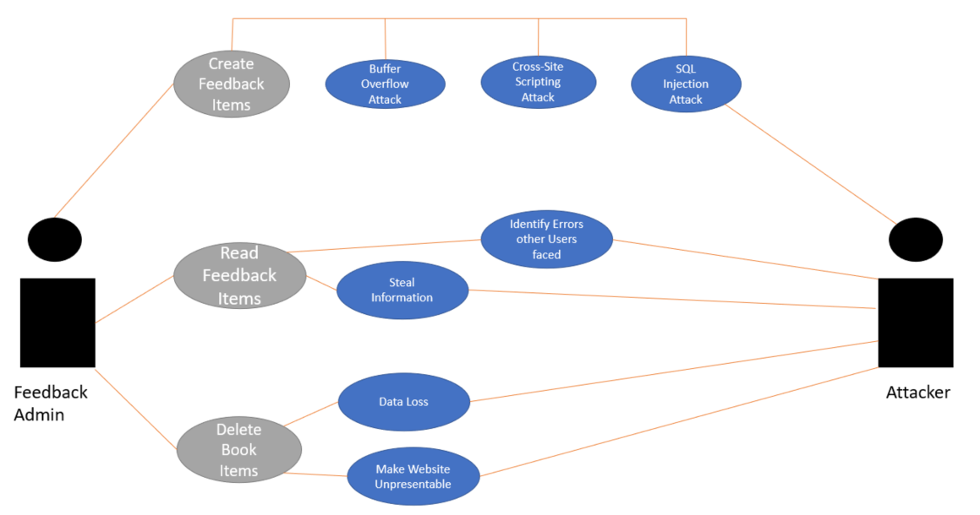

Figure 3.1.4.3: Misuse Case for Feedback Admin

For the fourth Misuse case, creating and updating permissions can be used by the attacker to corrupt the database . Audit items should be kept confidential and if the attacker has the ability to read the audit logs, he can steal this information and gain confidential information such as accounts’ email addresses. Deleting the audit items in the database will also lead to data loss and corruption.

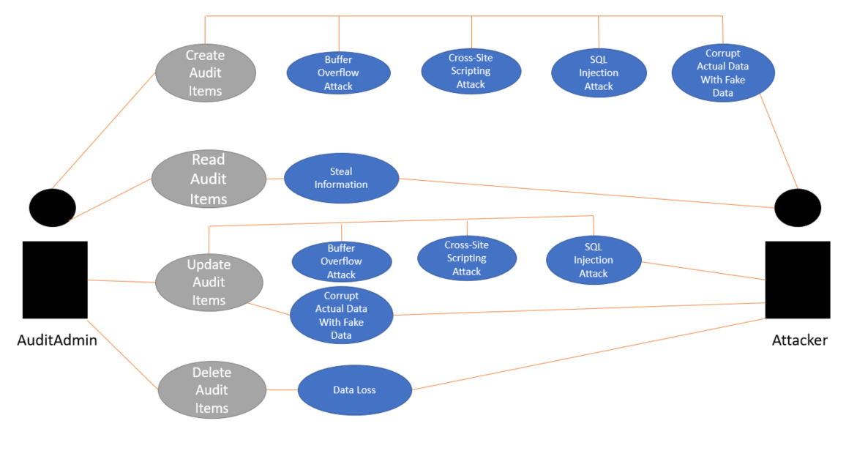

Figure 3.1.4.4: Misuse Case for Audit Admin

For the fifth Misuse Case, attackers having access to create and update items can result in errors in the website, causing the website to crash. Original data can also be replaced with fake data. For reading of items, not all are accessible to the public and thus if the attacker gains access to the database, they would be able to steal information from the database. If the attacker gains the ability to delete items as well, it will make the website stop functioning the way it is supposed to and can lead to data loss. If attackers have access to an account with the role “Admin”, the attacker will have power over everything and can destroy the website and database.

.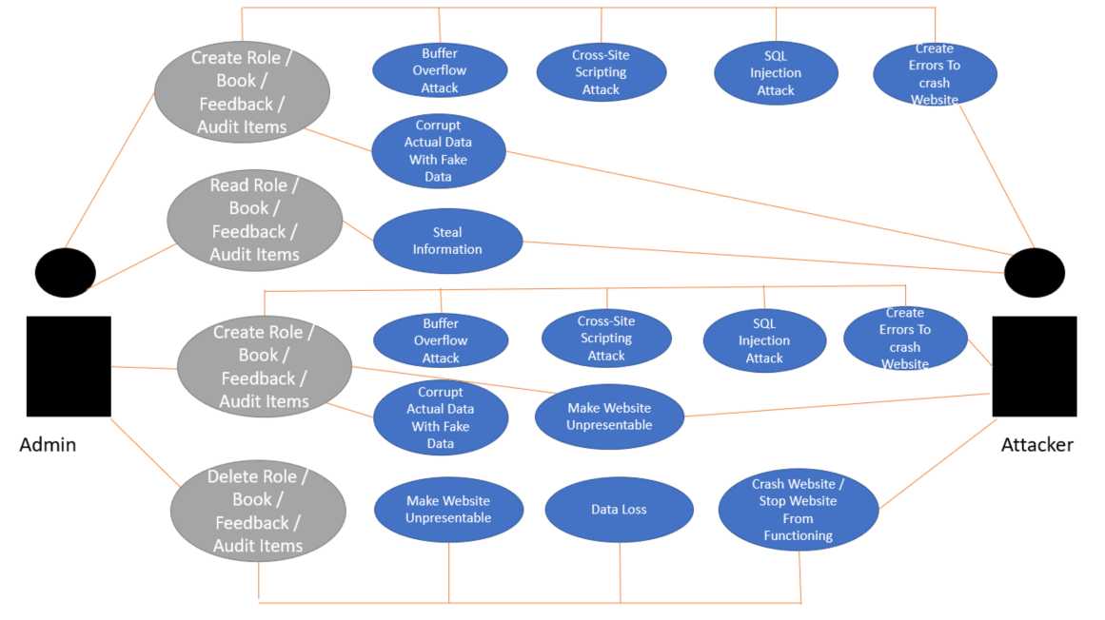

Figure 3.1.4.5: Misuse Case for Admin

# 3.2 Secure Software Design

A software is only considered a secure software when it has its features and pages designed to be secure from threats and exploitation. A software must be secure so that businesses waste less time identifying security issues in the future and can also provide its stakeholders with trust. Also, designing the software with security in mind, can help businesses uncover business logic flaws and other architectural design issues. Security features are usually kept consistent as well so it does not take much effort to change.

## 3.2.1 Features of Secure Software Design

There are some principles that a secure Software Design must have in correlation to authorization. One of the principles is least privilege which means that all accounts should have non-administrative abilities other than accounts which require administrative privileges. Another one of the principles is separation of duties which refers to the fact that the duties cannot be overlapped. For example, a programmer should not be able to review his own code. The next principle is defense-in-depth which means disabling active scripting to defend against XSS attack. The next principle is psychological acceptability which is to ensure that the interface is easy to use. The last principle is leveraging existing components which refers to reusing tested and proven existing libraries and common components.

## 3.2.2 Attack Surface Evaluation

### 3.2.2.1 Entry points

Entry points are search strings that take in user input. Each entry point can be a potential threat source. For Authorization, there are not many user inputs as there is nothing much for the user to interact with. One of the pages which requires a user input is the creation of the roles page. Another would be editing the name and description of the roles.

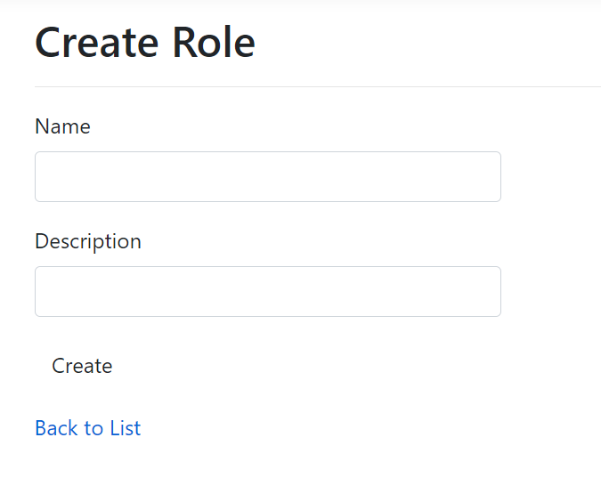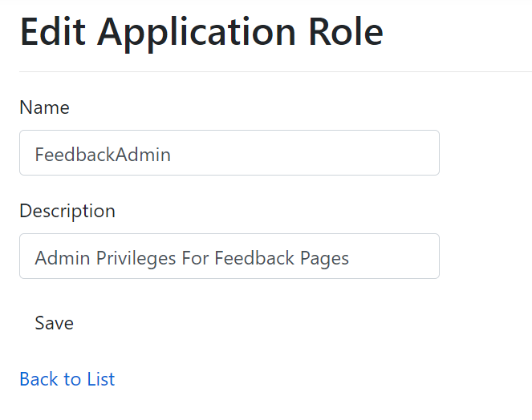

Figure 3.2.2.1.1: Entry Points In Role Creation And Edit

### 3.2.2.2 Exit points

Exit points are those items that display information from within the system. Exit points also include processes that take data out of the system and can be the source of information leakage. There are a few exit points that are part of the feature page. The first is the homepage where all the names and descriptions of the created roles are displayed. The second is the details page that displays details of a certain selected role and the last example is the management page which displays the role name, emails assigned to the role, and the number of users in the role.

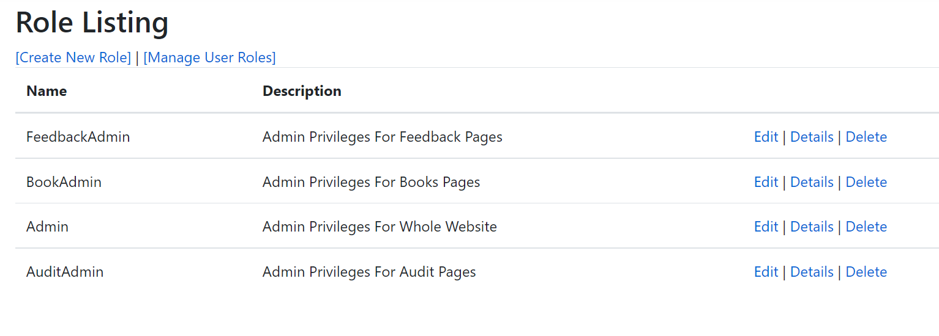

Figure 3.2.2.2.1: Home Page of Created Roles

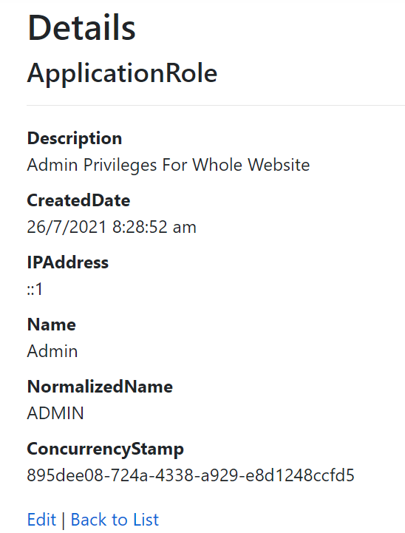

Figure 3.2.2.2.2: Details Page of Admin Role

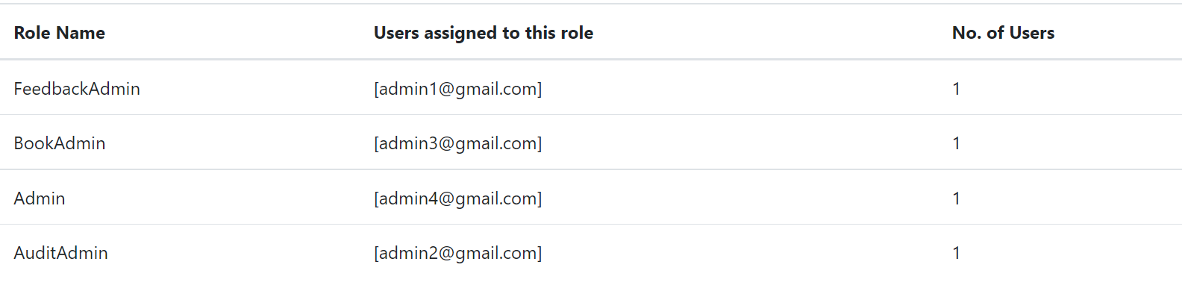

Figure 3.2.2.2.3: Management Page of Roles

## 3.2.3 Threat Modelling

### 3.2.3.1 Attack Trees

Attack trees model possible attacks that can happen and the methods that could be taken by the attacker to exploit and conduct the attack relating to the main topic. From the attack trees, areas of vulnerabilities and weaknesses are identified and can be focused on to make the software secure. There are a total of six attack trees made. One for Logging in, one for ordering book items, one for creating items, reading items, update items, delete items.

For logging in, four attacks have been identified. The first is the attacker's ability to impersonate user accounts. Attackers can steal user account credentials through many ways such as social engineering attacks, attacking the database or simply brute forcing their way. The next attack is a buffer overflow attack that overwrites memory of an application. The third attack is a cross-site scripting attack that launches an executable script in the program to allow attackers to gain access. The last attack is a SQL Injection attack that interferes with the queries made by the program to extract information out of the database. These last three attacks can only be executed from an input field.

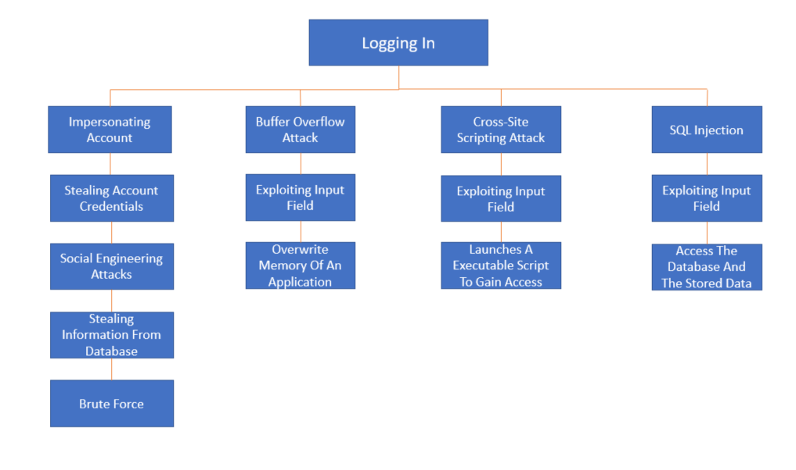

Figure 3.2.3.1.1: Attack Tree For Logging In

For ordering book items, four attacks have also been identified. The first attack is impersonating a user account, which can have unfavourable circumstances as attackers can buy book items without the original user even knowing. This can be done if attackers manage to steal payment information of the user. Payment Information could be saved to the account and attackers can steal the information from this feature. Payment information can also be stolen from the database or by getting intercepted by attacks through traffic eavesdropping. Similarly, the next three attacks are the buffer overflow attack, cross-site scripting attack and SQL Injection attack due to there being input fields when ordering book items.

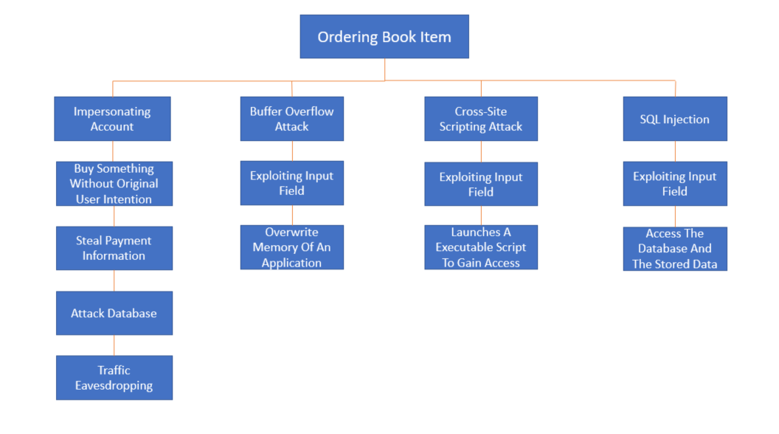

Figure 3.2.3.1.2: Attack Tree For Ordering Book Item

For creating objects, there are also four possible attacks an attacker can do. The first is the ability for the attacker to corrupt original data if they have the ability to create objects. Attackers can create unwanted objects to corrupt the website and can also create fake data to corrupt the database. Since creating objects have input fields, attackers also can conduct a buffer overflow attack, cross-site scripting attack, and SQL Injection attack. Attackers can create objects by impersonating an account with administrative privileges, or through code to update the database.

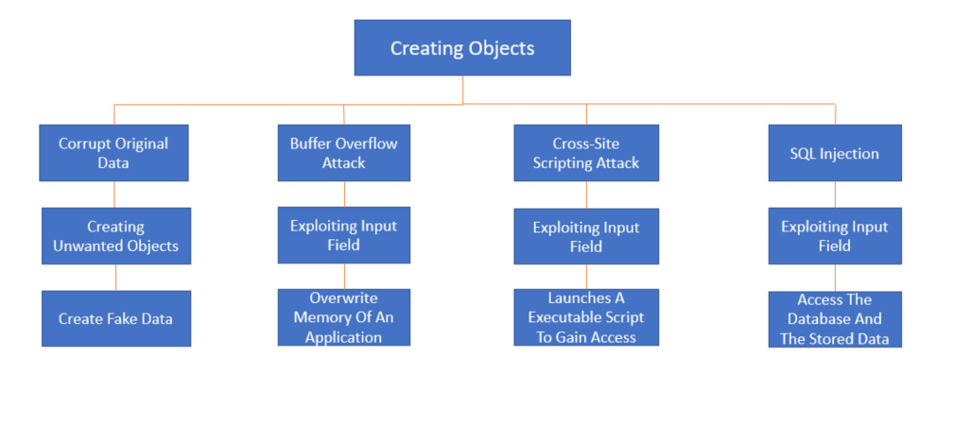

Figure 3.2.3.1.3: Attack Tree For Creating Objects

For reading objects, only one attack has been identified and that is the ability for the attacker to steal information. If attackers have been given access to read objects, confidential information such as email addresses can be leaked. Attackers can steal information by intercepting the transfer of information to the database, by attacking the database or by impersonating an account with admin privileges.

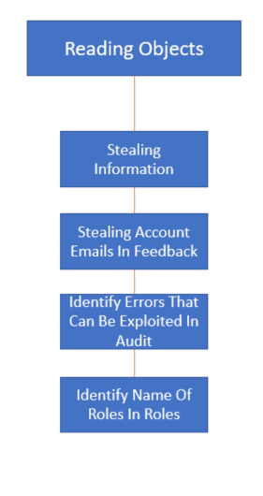

Figure 3.2.3.1.4: Attack Tree For Reading Objects

For updating objects, the attack threats are similar to creating objects, where the four attacks are the same. The only difference is that the way the attacker can corrupt original data is different. Data can be corrupted by updating existing objects to display fake and wrong information or to edit the objects to be illegible and hard to understand. Thus, attackers can make the website unpresentable or even worse, unusable. Attackers can update objects by impersonating an account with administrative privileges, or through code to modify the database.

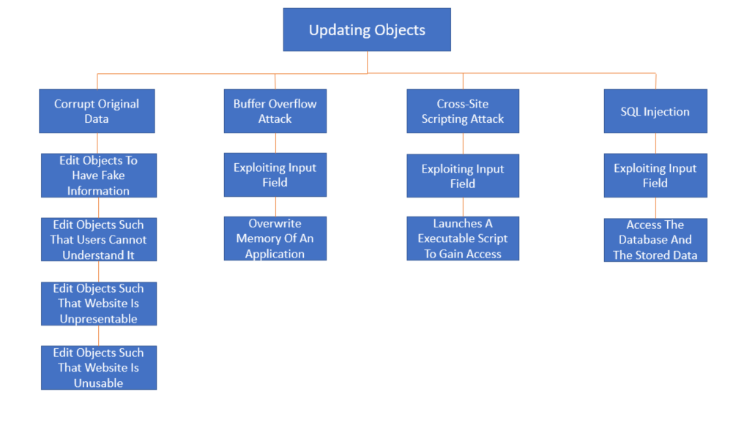

Figure 3.2.3.1.5: Attack Tree For Updating Objects

Lastly, if attackers gain access to delete objects, an attack threat would be loss of data. Attackers would be able to delete objects stored in the database which can destroy the website's presentation and can cause some functions or features to stop working. Attackers can impersonate accounts with higher admin privilege, attack the database, or through malicious code.

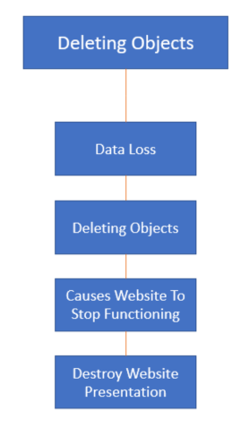

Figure 3.2.3.1.6: Attack Tree For Deleting Objects

### 3.2.3.2 STRIDE

STRIDE is an acronym for assessing a category of threats. S refers to Spoofing which refers to the ability for the attacker to impersonate another user identity. T represents Tampering which means that the ability to intercept and modify the data while it is in transit or in storage. R represents Repudiation which refers to seeing whether an action would be tracked so as to prevent attackers from denying the attack. It is Information Disclosure which is whether the information is disclosed to unauthorised users. D stands for Denial of Service which questions whether the software is resilient to denial of service attacks or not. Lastly, E stands for Elevation of Privilege which refers to the ability of the attacker to bypass least privilege implementation and to execute software at administrative levels.

#### 3.2.3.2.1 STRIDE Model

|  |  |  |  |
| --- | --- | --- | --- |
|  | Goal | Description | Threat |
| S | Spoofing | Ability of an attacker to impersonate another user or identity  Methods:  Attacking database  Brute force password  Social engineering attacks | Impersonating users / admins  Loss of personal information  Loss of accounts |
| T | Tampering | Ability of attacker tempering data during transit or stored in database  Methods:  Packet sniffer to eavesdrop  Attacking Database | Data loss  Stealing of account credentials |
| R | Repudiation | Ability of an attacker to do actions that will not be tracked | Impersonating accounts and do something that the original user has no intention of doing so |
| I | Information Disclosure | Information is not disclosed to unauthorised users  Methods:  SQL Injection attacks | Source code and command is leaked out  Users access admin-only pages and make changes  Loss of personal information |
| D | Denial of Service | Denial of Service is not possible  Methods:  Using automated bots to flood traffic to the website | Website crashes and is no longer available to users |
| E | Elevation of Privilege | No the attacker cannot execute the software at administrative privileges  Methods: Testing to reach restricted pages | Users access admin-only pages and have admin privileges  Modifies the website and delete items |

#### 3.2.3.2.2 Explanation of Stride Model

An attacker cannot impersonate another user or identity because the only information the attacker can steal related to other users are the account’s email addresses. Although the attacker can steal email addresses, the account’s password is not stored in the role’s database, and so the attacker cannot gain the credentials to impersonate someone. The only way the attacker can do so is by attacking the “NetUsers” database and stealing the credentials. Even if the attacker does manage to attack the “NetUsers” database, the passwords are hashed with SHA-256. The attackers would not be able to retrieve the password from the hashed values since hash values are not able to be reverted back to the original password, and thus will still not be able to access the account. Bruteforcing the password is also very hard for the attacker to do as there is a maximum number of tries to log in to the account before getting locked out. Social engineering attacks can only be solved on clients’ end to avoid phishing attacks.

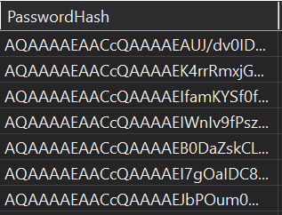

Figure 3.2.3.2.2a: Password Hash Values in Database

Data is not tampered with when data is in transit because the coding platform uses IIS security which supports encrypted HTTP connections using the Secure Socket Layer(SSL) protocol (Microsoft, 2019). Thus, when data is transferred, it prevents eavesdropping and is secure. Data stored in the database can only be accessed by administrators and also SQL Injection attacks do not work due to input sanitization, validation and proper error handling.

For Repudiation, audit logs will be used to track changes made to the roles. Thus, any account that deletes, creates, edits or assigns accounts to a role will be tracked and saved. This means that every user is responsible for their own actions and thus users cannot deny their actions.

Information is also not disclosed to the unauthorized users. Administrative access is required for the pages that are not available to the public to ensure that unauthorized users are not able to view crucial and key information. Public who visit the administrative pages accidentally or intentionally will have an error page. Error handling is done as well so that error pages do not show unnecessary information such as the code used to the users. Please refer to Figure 2.3.1.3.1 to see an example of a error message.

Denial of Service (DoS) cannot be done in the authorization feature. Due to the fact that DoS occurs by flooding the software with traffic or by sending information until the software crashes, Dos will not affect the Authorization feature of the software as only administrators can access the role pages and send information in these pages. Thus, automated bots cannot continuously send information into the input fields as the bots do not have the opportunity to do so (PaloaltaNetwork, n.d.).

There is no elevation of privilege in the software because roles have been assigned to certain pages and thus only accounts with the roles matching with the roles assigned to the pages, can access them. Thus, an attacker with a normal customer account will have limited actions and cannot perform actions on an administrative level. Customer Accounts that try to access resources that require administrative privileges will receive an error message stating “Access denied”. Please refer to Figure 2.3.1.3.1 to see the error message.

### 3.2.3.3 DREADi

DREADi is an acronym used for risk-assessing computer security threats. D refers to Damage which refers to how bad the impact an attack can have. R represents Reproducibility which means how easy an attack can be reproduced. E stands for Exploitability which refers to how easy the attack can be launched. A refers to Affected users which means how big the number of affected users are. Lastly, Di refers to Discoverability which refers to how easy the threat can be discovered (LogixConsulting, 2019). The scores in the DREADi Model are based on the OSSA Metrics.

#### 3.2.3.3.1 DREADi Model

|  |  |  |  |  |  |  |
| --- | --- | --- | --- | --- | --- | --- |
| Threat | D | R | E | A | Di | Average |
| SQL Injection | 3 | 3 | 2 | 3 | 2 | 2.6 |
| Cross-Site Scripting Attack | 3 | 3 | 3 | 3 | 3 | 3.0 |
| Buffer Overflow Attack | 3 | 3 | 2 | 3 | 2 | 2.6 |
| Audit Log Deletion | 1 | 1 | 1 | 1 | 3 | 1.4 |
| Data Eavesdropping | 2 | 1 | 2 | 3 | 2 | 2.0 |
| Deletion Of Data | 3 | 3 | 2 | 3 | 3 | 2.8 |
| Insecure Backup | 2 | 1 | 1 | 3 | 2 | 1.8 |
| Phishing | 2 | 3 | 3 | 3 | 2 | 2.8 |
| Impersonation of Admin | 3 | 2 | 2 | 3 | 3 | 2.6 |

In order to prevent these attacks from happening, secure software features such as input validation and proper role authorization must be done.

# 3.3 Secure Software Coding

## 3.3.1 Features of Secure Software Coding

### 3.3.1.1 Input Validation

Input Validation is the verification process that ensures that the data being supplied by the user is of the correct data type and format in order to prevent input to be interpreted as a code or to bypass security controls that can have devastating impact on the website. For the Authorization feature, there is not much input validation that is needed because there are very few entry points. However, an entry point still can be used by an attacker to attack the website. Thus, regex expressions are used in the “ApplicationRole” class to ensure the user input has no malicious character (Microsoft, 2021). Another validation used is [Required] to ensure that the user does not submit null values (Microsoft, 2011).

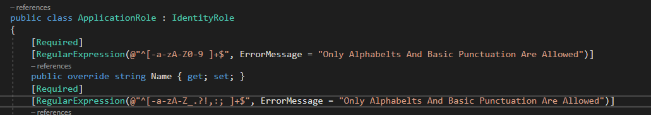

Figure 3.3.1.1.1: Regex Expression Used For Input Validation

### 

Figure 3.3.1.1.2: Usage of BindProperty

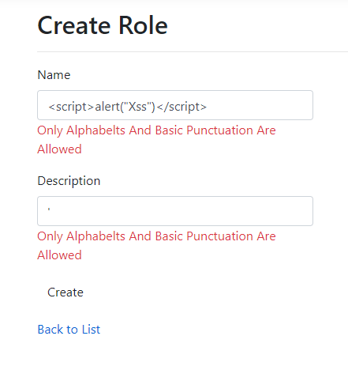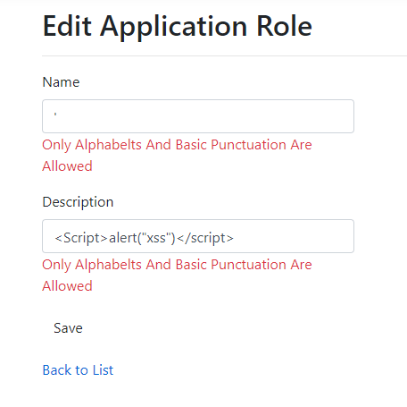

Figure 3.3.1.1.3: Validation Being Used in Entry Points

### 3.3.1.2 Input Sanitization

Input Sanitization is the process of transforming user input before being processed by the website. ASP NET conducts input sanitization automatically and takes the input as its literal form (HowtoASP.Net, 2021). Thus, additional input sanitization is not needed to be included.



Figure 3.3.1.2.1 : Input Sanitization Being used

As seen from the screenshot above, when a cross site scripting command is being inputted into the field, the code was not executed and runned, but instead is saved into the database

### 3.3.1.3 Error Handling

For Authorization, when a customer tries to gain access to a webpage that requires a role such as “admin” for example, the customer will not be able to access the webpage and all that will be displayed will be an error message stating that the customer does not have access to the resource.

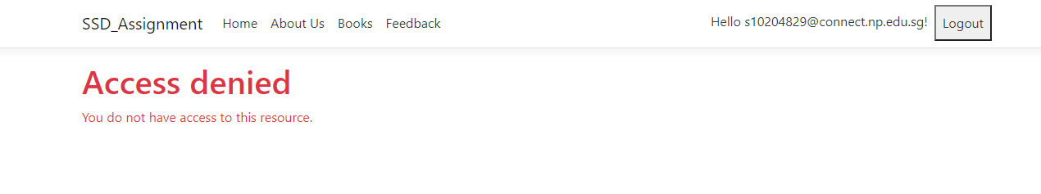

Figure 3.3.1.3.1: Error Handling When Someone access a administrative page with the wrong role

### 3.3.1.4 Proper Role Management

For Authorization, each page must be ensured that only accounts associated with the correct roles can access specified pages. This will prevent attackers who are using a customer account to gain access to these restricted pages to create attacks. Thus, “Authorise(Roles = “[AdminName1]”) was used in the code such that only accounts that have a role that matches the [AdminName1] can access the pages.

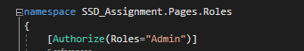

Figure 3.3.1.4.1: Showing Usage of Proper Role Management

## 3.3.2 Secure Software Processes

### 3.3.2.1 Versioning

The software used by everyone in the group was the same as everyone used ASP.NET Core Web Application. A total of 10 packages were installed and used. These packages include AntiXss Version 4.3.0, Microsoft.AspNetCore.Authentication.Facebook Version 3.1.15, Microsoft.AspNetCore.Authentication.Google Version 3.1.15, Microsoft.AspNetCore.Authentication.MicrosoftAccount Version 3.1.15, Microsoft.AspNetCore.Identity.EntityFrameworkCore Version 3.1.15, Microsoft.AspNetCore.Identity.UI Version 3.1.15, Microsoft.EntityFrameworkCore.SqlServer Version 3.1.15, Microsoft.EntityFrameworkCore.Tools Version 3.1.15, Microsoft.VisualStudio.Web.CodeGeneration.Design Version 3.1.15, and SendGrid Version 9.24.1. Bitbucket was used as well so that changes to the code could be tracked and shared with one another.

### 3.3.2.2 Code Analysis

The platform used was Visual Studio and it is an integrated development environment and thus provides static code analysis. It highlights to the user where errors are by underlining mistakes. Thus, by using Visual Studio, errors are identified almost immediately. For Dynamic code analysis, many testings were done when the program was run. It was tested to see whether transferring between pages were successful, whether features are meant to perform the way they are meant to be, and whether it can withstand attacks. “If” statements were used as well to give an indication to see if some of the features were successfully working.

### 3.3.2.3 Code/Peer Review

Everyone in the group did their own fair share of testing and reviewing on one another codes to spot for errors. Each one tested the other person’s feature to see if it is functioning as it is expected to be, and to test if it is secure.

OWASP ZAP, a security tool that can be used to check how secure a software is, was also used to check how secure the website we created was.

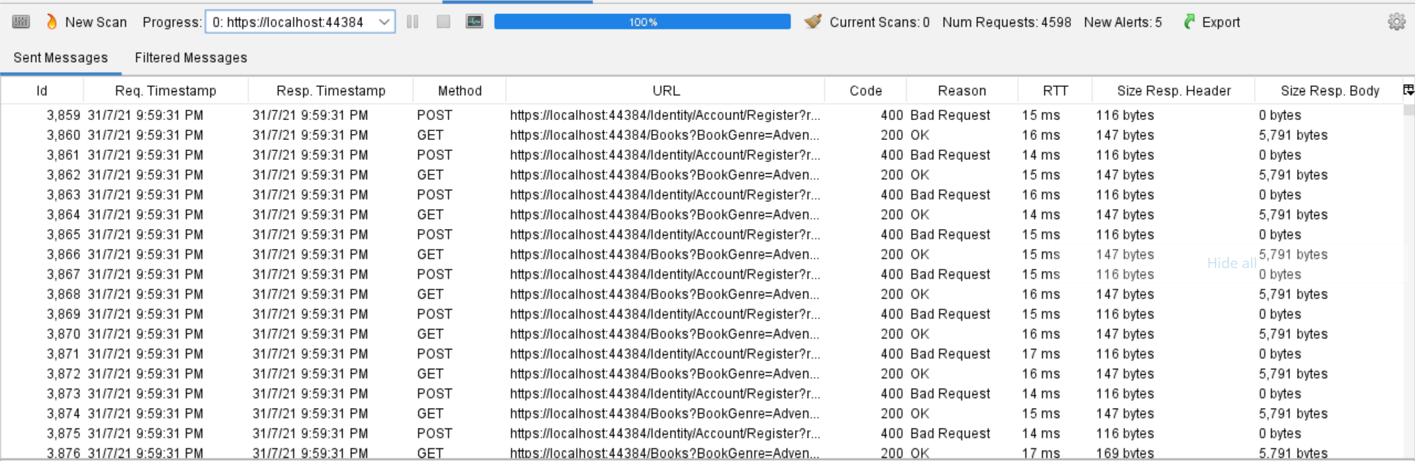

Figure 3.3.2.3.1: OWASP ZAP Scan Output



Figure 3.3.2.3.2: OWASP ZAP Scan Alerts

From the screenshots, the website seems to be quite secure as out of the 4598 processes scanned by the tool, there were only 12 alerts flagged by the tool. Thus, the website is quite secure.

# 3.4 Secure Software Testing

There are many different types of security tests that can be performed to check the security of the code developed. Some of the security tests that were conducted during this assignment include testing for input validation, testing for Injection Flaws Controls, testing for Scripting Attacks Controls, testing for Non-Repudiation Controls, testing for Error and Exception Handling Controls, and testing for Privileges Escalation Controls.

## 3.4.1 Test Strategy

The test strategy taken to ensure the authorization feature is working as intended to be followed as such. Firstly, for the needed resources for testing, four roles needed to be created and stored in the database, and a total of five accounts needed to be created, one linked to each role and the last having no role. Using these five accounts, it was tested to see which accounts can access which resources. The goal of this is to see if the accounts associated with the roles are only able to access and see only what they should be seeing. The method to do so will be a step-by-step process in which each role will be tested on their ability to test their accessibility to certain pages. Additionally, the entry points for creation of roles and editing of roles will also be checked to ensure that it is secure.

## 3.4.2 Test Plan

|  |  |  |
| --- | --- | --- |
| Test Requirements | Test methods | Test Coverage |
| Validate role create and edit input fields | Check if malicious characters can be used  Check if scripts can be runned  Check if null is submitted  Check if data inputted is in correct format | Ensures that the entry points for creating and editing input fields are secure and in the correct format |
| Use a customer account (No admin privileges) | Check ability to access admin-only pages such as “Roles”  Check ability to see links that are only available to this role | Ensures that the customer account cannot access restricted pages  Ensures that the customer can only see links that are available to the role |
| Use a “BookAdmin” account | Check ability to access other admin-only pages such as “Roles”  Check ability to see links that are only available to this role | Ensures that the “BookAdmin” account can only access pages that are within Book Pages  Ensures that the “BookAdmin” accounts can see the links they are supposed to see in Books Page |
| Use a “FeedbackAdmin” account | Check ability to access other admin-only pages such as “Roles”  Check ability to see links that are only available to this role | Ensures that the “FeedbackAdmin” account can only access pages that are within Feedback Pages  Ensures that the “FeedbackAdmin” account can see the links they are supposed to see in Feedback’s Page |
| Use a “AuditAdmin” account | Check ability to access other admin-only pages such as “Roles” | Ensures that the “AuditAdmin” account can only access pages that are within Audit Pages |
| Use a “Admin” account | Check ability to access other admin-only pages such as “Roles” | Ensures that the “Admin” account can access all pages |

## 3.4.3 Test Cases

|  |  |  |  |  |
| --- | --- | --- | --- | --- |
| ID | Requirement Specification | Testing Approach | Expected Results | Goal Achieved |
| 1. | Entry Points (Input Fields) | Test out malicious characters such as “<>’;:\-.”  Test out script codes such as “<script>alert(“test”)</script>”  Test for null input  Test to input numbers or floating numbers | Error message (“Only Alphabets can be used”) | Success |
| 2. | Use a Customer account | Test whether the user can access admin-only pages | Customer cannot access admin-only pages such as Book/Create.cshtml or Role/Index | Success |
| 3. | Use a Customer account | Test to see whether the user can see administrative links, “Create, Edit, or Delete” in the Books Page | Customers can only see one link in Books Page that leads to Details | Success |
| 4. | Use a Customer account | Test to see whether the user can see administrative link, “Feedback Details” in the Feedback Page | Customers cannot see the link in the Feedback Page | Success |
| 5. | Use a BookAdmin account | Test to see whether the user can access pages,“Roles,Audit, or Feedback Details” | “BookAdmin” accounts cannot access “Roles, Audit, and Feedback Details” | Success |
| 6. | Use a BookAdmin account | Test to see whether the user can see administrative links such as “Create, Edit, or Delete” in Books Page | “BookAdmin” accounts can see and access the “Create, Edit, and Delete” pages | Success |
| 7. | Use a FeedbackAdmin account | Using a “FeedbackAdmin” administrative account, see whether the user can access pages,“Roles, Audit, Books Create, Books Edit, or Books Delete” | “FeedbackAdmin” accounts cannot access the “Roles, Audit, Books Create, Books Edit, and Books Delete” pages | Success |
| 8. | Use a FeedbackAdmin account | Using a “FeedbackAdmin” administrative account, see whether the user can access the page “Feedback Details” | “FeedbackAdmin” accounts can see and access the page “Feedback Details” | Success |
| 9. | Use an AuditAdmin account | Using an “AuditAdmin” administrative account, see whether the user can access pages, “Roles, Books Create, Books Edit, Books Delete, or Feedback Details” | “AuditAdmin” accounts cannot access the “Roles, Books Create, Books Edit, Books Delete, or Feedback Details” pages | Success |
| 10. | Use an AuditAdmin account | Using an “AuditAdmin” administrative account, see whether the user can access “Audit” pages | “AuditAdmin” accounts can access “Audit” Pages | Success |
| 11. | Use an Admin account | Using an “Admin” account, see whether the user has access to every page | “Admin” accounts can access every page | Success |
| 12. | Use all accounts | Check to see if all accounts from different roles can see the items and access the details page in the index page of Books | Every role can see the items and access the details page in the index page of Books | Success |

# 3.5 Security Conclusion of the Feature

All in all, authorisation is an important requirement to have in order to make a software secure. It creates restrictions on pages with classified information, as well as prevents anyone from creating their own objects, updating or deleting existing objects in the website. Authorization is needed so that the website can continue to function as expected without much discrepancies. Furthermore, other security features such as input validation is closely connected to Authorization and both must be used to ensure the website is secure. Authorization is only one requirement out of the many requirements that makes a website secure, but it surely is one that should not be overlooked.

# 4. CRUD Database

A CRUD database is a database that contains the four basic and necessary functions needed to implement persistent storage. These functions include create, read, update and delete (CRUD). A persistent database is a database that retains data even after the database’s device is shut down.

# 4.1 Secure Software Requirements

A secure software application has three quality attributes, reliability, resiliency and recoverability. Reliability refers to the capability of the software to maintain a high level of performance under certain conditions for a period of time. Resiliency refers to the ability of the software to withstand events, expected and unexpected, which may be harmful to the software. Recoverability refers to the ability of the software application to restore operations to an expected level after failure or damage caused by attacks and threats by limiting damage.

## 4.1.1 Use Cases and Misuse Case modeling

Use cases model the expected behavior of the software application and describe the intended behavior of the software by the designer. Use cases are also useful for specifying software security and functional requirements.

For the use case surrounding the CRUD database, the perspective of the Admin role will be used to state all the possible database operations as the Admin role has admin privileges to the entire database.

The Admin role is the only role to have access to all the database operations in the software application. The Admin role is able to create, read, update and delete objects in Books, Feedback, Audit and Roles.

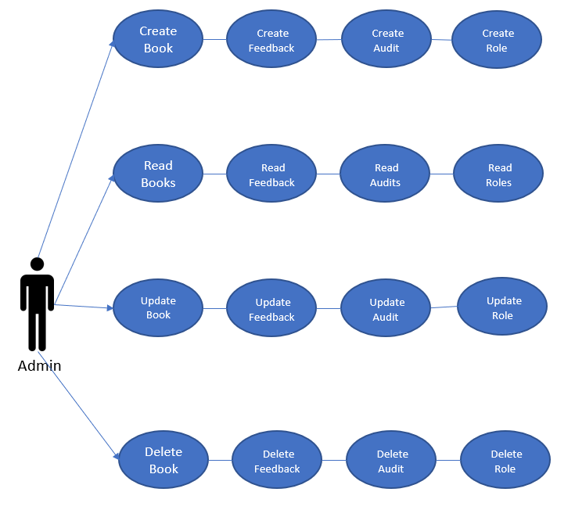

Figure 4.1.1.1: Use Case for Admin which contains all database operations

Misuse case modeling refers to modeling negative and unintended scenarios which can be effective in identifying software security requirements. Misuse cases refer to malicious acts against the software system. This can help companies or businesses gather valuable knowledge on how to mitigate these threats and find security measures that can increase the quality and security of the system.

In this misuse case, attackers who gain unauthorized access to the create and update operations can perform cross-site scripting attacks, SQL injections, buffer overflow attacks and commit website defacement. Attackers who are able to update roles can grant themselves roles with high permissions and have unauthorised access to confidential resources in the system. Attackers who gain access to the read operation can perform cross-site scripting attacks and inject malicious SQL code in order to steal confidential information from the database. Attackers who gain access to the delete operation can contribute to data loss in the database.

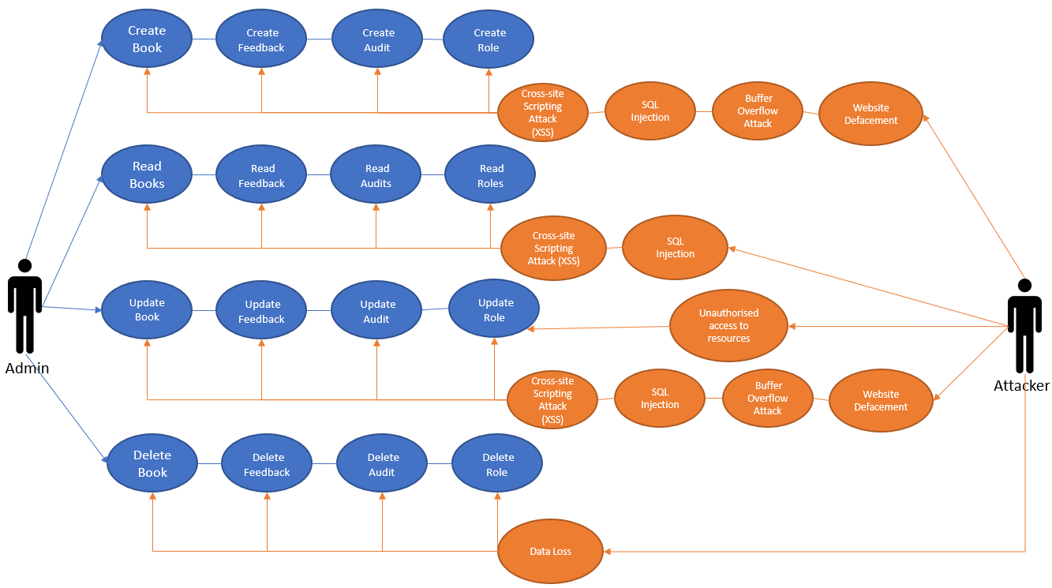

Figure 4.1.1.2: Misuse Case for Admin which contains all database operations

## 4.1.2 Data Labelling and Classification

Data Classification refers to the assignment of labels on data and information. These labels are based on its sensitivity and potential impact to confidentiality, integrity and availability.

|  |  |  |  |
| --- | --- | --- | --- |
| Data | Confidentiality | Integrity | Availability |
| Book data | Low | Medium | Low |
| Feedback data | Low | Medium | Low |
| Role data | High | High | High |
| Audit data | High | High | High |
| Payment data | High | High | Medium |

For the CRUD database, five potential data points have been identified. The first data point is the book data. Information on the books is publicly available and can be read by all types of users, even unregistered users. Hence, the book data does not need to be kept confidential. The book data should not be tampered with by unauthorised users as books may be mistaken for other books or the description or image cover for the book may be inaccurate. However, modifying book data will not cause critical damages to the system or any users as the books can be replaced or modified to resemble their original selves. Hence, the level of integrity for book data is medium. Book data should be available at all times and users should not be denied access to book information. However, denial of access to book information will only be an annoyance at its worst and no important information is denied access to any user. Hence, the book data level of availability is low.

The second data point is the feedback data. The feedback information is publicly available to all users and is not confidential, hence its level of confidentiality is low. Feedback data should not be tampered with by unauthorized users. However, no critical damages will be caused by changing feedback data as it does not affect any user or the system to a large extent. Hence, the level of integrity for feedback data is medium. Users or the system will not suffer any damages for not being able to access feedback data, hence the availability level for the feedback data is low.

The third data point is the role data. The role data, such as role name and users associated with the role, is confidential and should only be made available to the Admin role. If publicly available, the attacker can impersonate a role with permissions in the system, perform malicious actions and cause critical damages to the software. Hence, the level of confidentiality for role data is high. The role data should not be tampered with as modifications to the role data can cause authorised users to not be granted access to parts of the system needing authorisation as the system will not recognise the modified role that the user has. This can cause critical damage to the system, hence the level of integrity for role data is high. Role data should be made available to authorised users at all times. Unauthorised modification of role data may result in denial of access to important parts of the system to authorised users and disrupt the business, causing significant damages to the system. Hence, the level of availability for role data is high.

The fourth data point is the audit data. The audit data, which includes the subject, the action, the object on which the action was performed and the timestamp of the action,needs to be confidential. Making it available to attackers can inform them on all the different actions taken by all users and how to better attack the system. Hence, the level of confidentiality is high. The audit data should definitely not be tampered with. Accountability and non-repudiation of the system can be damaged due to modifications or deletions of audit data by attackers. This can remove the ability to hold attackers accountable for any attacks they perform on the system and attackers can deny malicious actions taken to damage the system. Therefore, it is vital that audit data is not modified. Hence, the level of integrity for audit data is high. It is important for audit data to be available at all times. If audit data is not accessible, attackers cannot be held accountable for damages and attacks on the system. Hence, the level of availability for audit data is high.

The fifth data point is payment data. Payment data includes highly sensitive information such as card number, card CSV, address, postal code and phone number. The payment information being confidential is critical as attackers can impersonate the victim and make transactions without their consent, resulting in huge monetary losses and damages, if attackers get their hands on this confidential payment data. Hence, the level of confidentiality for payment data is high. Payment data should not be modified in the database by unauthorised users. Hence, the level of integrity for payment data is high. Payment data should be made available to the user at all times. The user may not be able to purchase any books if the user is denied access to his saved payment data from the database. However, the user can still enter his payment information to make a purchase without needing to retrieve the saved payment data from the database. Hence, the level of availability for payment data is medium.

## 4.1.3 Subject/Object Matrix

A subject/object matrix is a two-dimensional table that represents roles and components and specifies the allowable actions, such as the create, read, update and delete operations, between subjects and objects based on use cases. A subject/object matrix is effective in generating misuse cases. Potential threats can be determined by inversing the allowable actions captured in the subject/object matrix. This allows businesses and companies to iron out vulnerabilities and mitigate threats to the system.

|  |  |  |  |  |  |
| --- | --- | --- | --- | --- | --- |
| Objects | Customer | Book Admin | Feedback Admin | Audit Admin | Admin |
| Books | Read Book Info | Create Book Info  Read Book Info  Update Book Info  Delete Book Info | Read Book Info | Read Book info | Create Book Info  Read Book Info  Update Book Info  Delete Book Info |
| Feedback | Create Feedback Info | Create Feedback Info | Create Feedback Info  Read Feedback Info  Delete Feedback Info | Create Feedback Info | Create Feedback Info  Read Feedback Info  Delete Feedback Info |
| Roles | NIL | NIL | NIL | NIL | Create Role Info  Read Role Info  Update Role Info  Delete Role Info  Manage Role Info |
| Audit | NIL | NIL | NIL | Create Audit Info  Read Audit Info  Update Audit Info  Delete Audit Info | Create Audit Info  Read Audit Info  Update Audit Info  Delete Audit Info |
| Payment | Create Payment Info  Read Payment Info  Update Payment Info | Create Payment Info | Create Payment Info | Create Payment Info | Create Payment Info |
| Cart | Create Cart Info  Read Cart Info  Update Cart Info  Delete Cart Info | Create Cart Info  Read Cart Info  Update Cart Info  Delete Cart Info | Create Cart Info  Read Cart Info  Update Cart Info  Delete Cart Info | Create Cart Info  Read Cart Info  Update Cart Info  Delete Cart Info | Create Cart Info  Read Cart Info  Update Cart Info  Delete Cart Info |
| About Page | Read About Page Info | Read About Page Info | Read About Page Info | Read About Page Info | Read About Page Info  Update About Page Info |

In the subject/object matrix, there are seven objects and five roles. The objects include the books page, the feedback page, the roles page, the audit page, the payment page, the cart page and the about page. The roles include Customer, Book Admin, Feedback Admin, Audit Admin and Admin.

For the books database, the customer, feedback admin and audit admin can only perform the read operation while the book admin and admin can create, read, update and delete book objects.

For the feedback database, the customer, book admin and audit admin can only perform the create operation while the feedback admin and the admin can create, read and delete feedback objects.

For the roles database, only the admin can create, read, update, delete and manage the user roles The rest of the roles, customer, book admin, feedback admin and audit admin cannot perform any operations on the roles page.

For the audit database, the customer, book admin and feedback admin cannot perform any operations while the audit admin and the admin can perform create, read, update and delete operations on the audit database.

For the payment database, the customer can create, read and update his payment details. To ensure confidentiality, the other roles, book admin, feedback admin, audit admin and admin, are not able to access and perform any operations on the customer’s payment information.

For the cart, all roles can create, read, update and delete items from their cart before check out.

For the about page, all roles can read the contents of the about page while only the admin can update the contents of the page.

Hence, the admin is the role with the most permissions in the whole system. The book admin, feedback admin and audit admin have the most permissions in their respective object databases. The customer is the only role with the least permissions and cannot create, update or delete items in most of the object databases.

# 4.2 Secure Software Design

Secure software design refers to the incorporation of security during the software development process. Security is kept in mind when designing software. This iron outs vulnerabilities early on in the software development process and prevents attackers when exploiting potential holes in security to damage the system. Secure design also drastically reduces the time taken to fix identified security issues in the system. Hence, this allows the software to be reliable, resilient and recoverable.

## 4.2.1 CRUD Database related security design

One secure software design principle for the CRUD database includes hashing. Hashing is the process of passing in data through a hashing function to produce a result, which is referred to as a hash. Hashing is usually used to store highly confidential information such as passwords and card PINs. For example, when a bank customer inserts his bank card into the ATM, the ATM reads the hashed value of the card PIN which is stored in the card. The ATM then hashes the PIN number entered by the bank customer using the same hashing algorithm and compares the hash with the card hash. If both hashes match, the user is then able to access the ATM. Additionally, the stored hashes may be salted to ensure no two password hashes are the same, even if the passwords passed through the hashing functions are the exact same. Likewise, in this database, user passwords are stored in their hashed value state. Hence, hashing maintains data integrity.

Another secure software design principle for the CRUD database includes referential integrity, Referential integrity utilises primary keys and foreign keys in the relational database to ensure data integrity. For example, if a user is deleted or updated in the database, corresponding role records have to be deleted or updated respectively to ensure referential integrity. This ensures that a role record does not exist without being tied to a user. Hence, referential integrity ensures data integrity.

## 4.2.2 Attack Surface Evaluation

### 4.2.2.1 Entry Points

Entry points refer to input boxes in the web application that take in user input. Input is then used to interact with the database and search for the desired data and information. There are many entry points from multiple pages that access the database.

For the books page, there is a search filter in the books index page and takes in a string and returns books with titles that contain the input string. Please refer to Figure 5.1.1.1 for an image of the Books Index Page.

There are also entry points in the books create and edit pages.

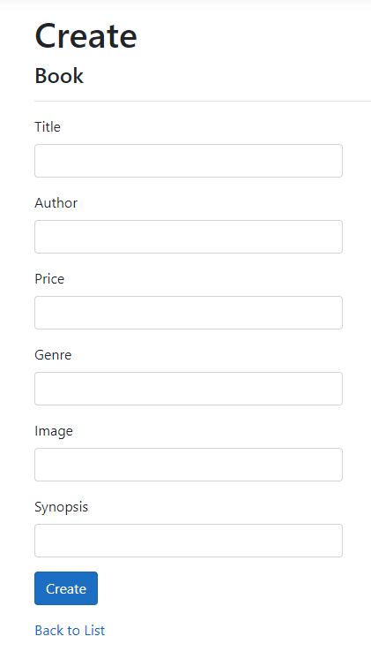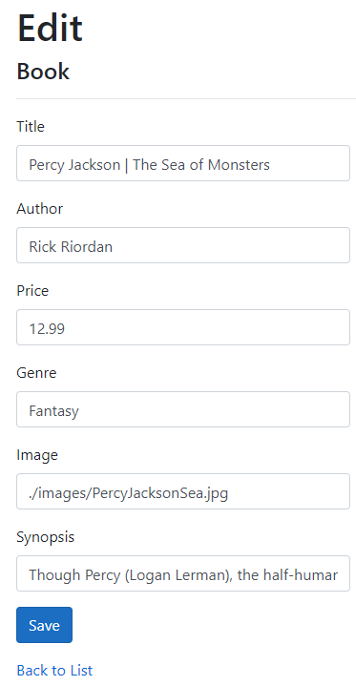

Figure 4.2.2.1.2: Entry Points in Books Create And Edit Page

For the feedback form page, there are entry points in the feedback form for creating feedback. Please refer to Figure 5.4.1.1 for the image of the feedback form.

For the roles page, there are entry points in the roles create and edit pages and can be seen in Figure 3.2.2.1.1

For the audit page, there are entry points in the audit create and edit pages.

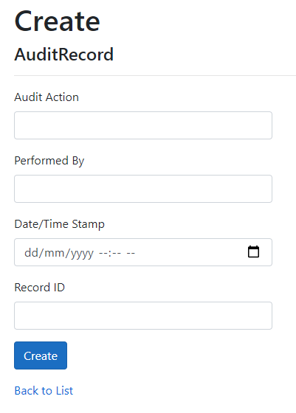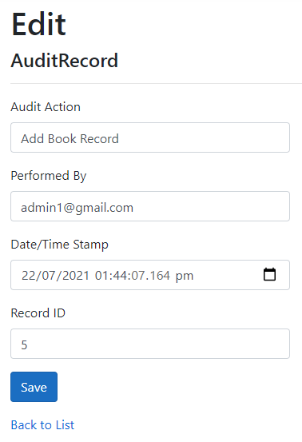

Figure 4.2.2.1.3: Entry Points in Audit Create And Edit Page

For the payment page, there are entry points in the payment page. An image of the payment page can be found in Figure 5.3.1.1

### 4.2.2.2 Exit Points

Exit points refer to items in the web application that display information and retrieve data from the database. These exit points can be the source of information leakage from the database, thus they need to be secured. There are many exit points for the information from the databases of the different objects.

For the books page, an exit point includes the information about the books such as the book title and price. There are also exit points in the details page about the respective books. The books page can be seen at Figure 5.1.1.1 and a book details page can be seen at Figure 5.1.1.2

For the roles page, exit points include the information about the roles such as name and description in the roles index page. There are also exit points in the details page for each role, which can be seen at Figure 3.2.2.2.1, Figure 3.2.2.2.2, and Figure 3.2.2.2.3.

For the audit page, exit points include the information about the audits displayed in the index page and the details about each audit in the details page.

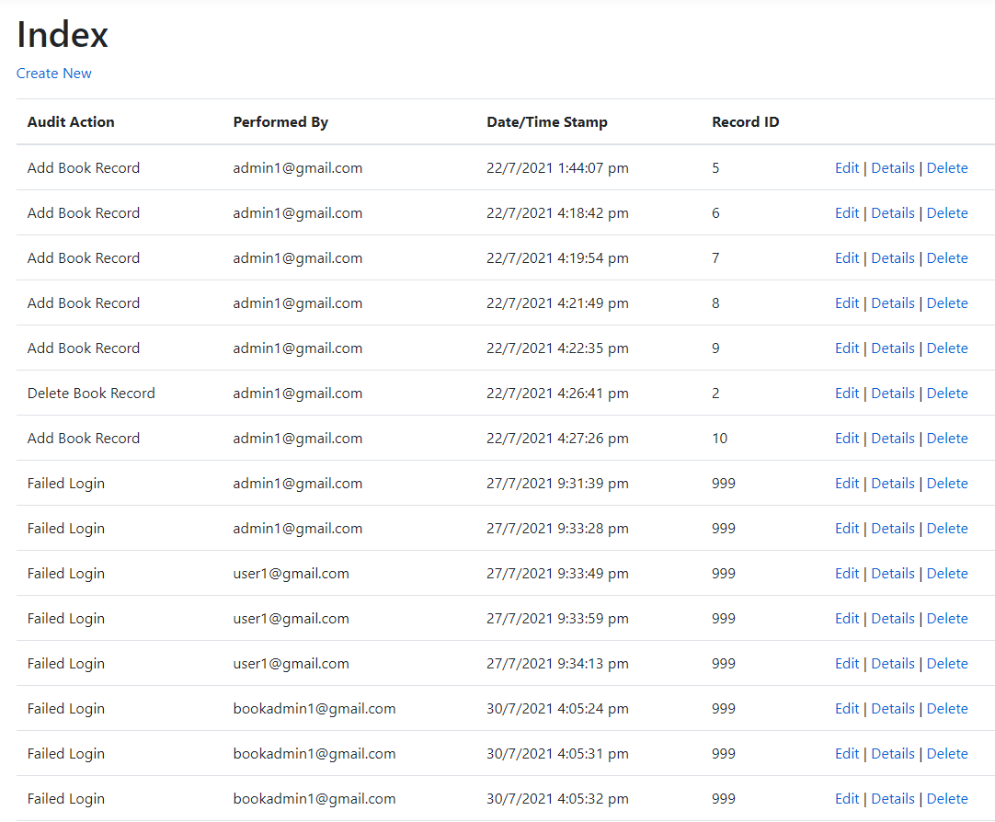

Figure 4.2.2.2.5: Exit Points in Audit Index Page

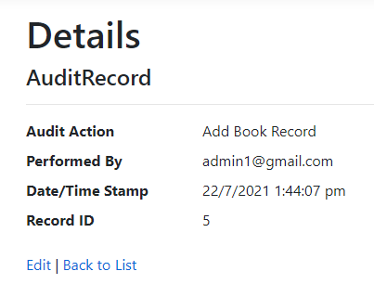

Figure 4.2.2.2.6: Exit Points in Audit Details Page

## 4.2.3 Threat Modeling

Threat modeling is a security technique during the design phase of the software development process. Threat modeling provides an attacker’s viewpoint and helps to point out vulnerabilities within the application that attackers can exploit. Hence, threat modeling is critical in developing secure software.

### 4.2.3.1 Attack Tree

Attack trees refer to diagrams that depict attacks on the application in a tree form. The root of the tree represents the goal of the attacker, while the leaves represent the methods and strategies that can be used by the attacker to achieve the goal.

For the CRUD database, one possible attack is to steal customer payment information.

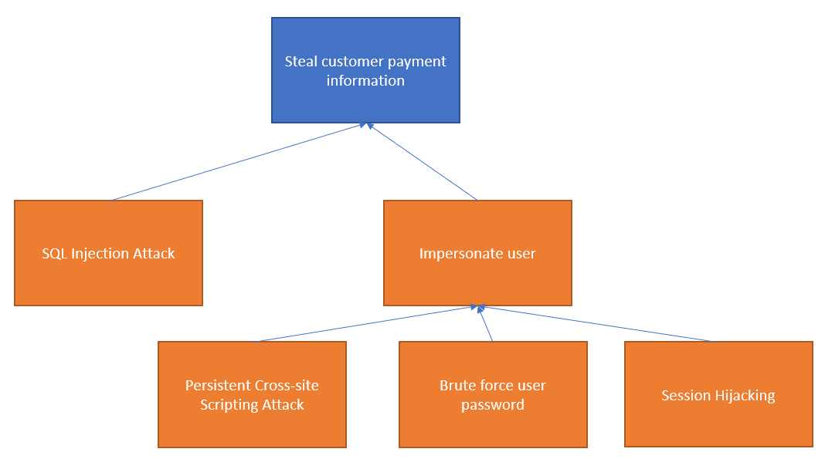

Figure 4.2.3.1.1: CRUD Database Attack Tree

There are multiple ways for an attacker to steal payment information from the database. One method is to inject malicious SQL code through an entry point in the payment page to retrieve confidential payment information from the database. Another method is to perform a persistent cross-site scripting attack on the database. An attacker can clone the login page of the application and use cross-site scripting vulnerabilities to serve it to victims. When the victim uses the vulnerable web page and inputs their credentials, the attacker then retrieves the user’s input. This way, the attacker is able to obtain the user credentials and hence impersonate the user and steal the confidential payment information. Another method is to use brute force until the attacker finally cracks the victim’s password, resulting in impersonation of the victim and stealing of the victim's payment information. Another method is to perform session hijacking whereby the attacker steals the victim’s valid session token and gains access to the victim’s account, thus being able to steal the victim’s credentials.

### 4.2.3.2 STRIDE

STRIDE refers to a category of threats which include spoofing, tampering, repudiation, information disclosure, denial of service and elevation of privilege. STRIDE is a goal-based approach to threat modeling as the goals of the attacker are taken into consideration.

|  |  |  |
| --- | --- | --- |
|  | Goal | Identified Threats |
| S | Spoofing | Session Hijacking  Cross-site Request Forgery |
| T | Tampering | SQL Injection |
| R | Repudiation | Audit Log Deletion |
| I | Information disclosure | Information Leakage |
| D | Denial of service | Website Defacement Buffer Overflow Attack |
| E | Elevation of privilege | Logic Flaw |

The attacks that achieve the goal of spoofing include session hijacking and cross-site request forgery attack. Session hijacking involves the stealing of a valid session token, resulting in gaining access to the victim’s session and being able to impersonate the victim. Cross-site request forgery attack involves running a malicious script on a trusted site while the victim is still authenticated, hence the attacker is able to impersonate the victim and gain access to sensitive information.

The attack that achieves the goal of tampering is SQL injection. SQL Injection involves injecting malicious SQL code into the web application through entry points such as input boxes in order to tamper with data in the database and cause damage to the system.

The attack that achieves the goal of repudiation is audit log deletion. Without audit logs, attackers cannot be identified or be held accountable for any damages caused to the system.

The attack that achieves the goal of information disclosure is information leakage attack. This includes exploiting a web application to reveal sensitive information through items such as error messages.

The attacks that achieve the goal of denial of service include website defacement and buffer overflow attack. Users may be denied access to the web application’s services due to the changing of contents on the website. Buffer overflow attack can cause the web application to behave unpredictably or crash due to failure to allocate enough space for the buffer, hence denying access to services for users.

The attack that achieves the goal of elevation of privilege is logic flaw. Unidentified vulnerabilities in the web application due to poor incorporation of secure design principles can result in these vulnerabilities being exploited by attackers to gain higher permissions in the system.

### 4.2.3.3 DREAD ranking

DREAD is a risk assessment model that identifies the severity of threats to an application. DREAD is an acronym for the five criterias to assess threats, damage, reproducibility, exploitability, affected users and discoverability. Damage criteria ranks the potential damage when the vulnerability is exploited or the threat transpires. Reproducibility criteria ranks the ease of ability to recreate the threat and the frequency of the threat. Exploitability criteria ranks the effort needed for the threat to be manifested. Affected Users criteria ranks the number of users or system components that will be affected by the materialised threat. Discoverability criteria ranks the ease of external researchers and attackers being able to discover the threat.

|  |  |  |  |  |  |  |
| --- | --- | --- | --- | --- | --- | --- |
| Threat | D | R | E | A | Di | Average rank  (D+R+E+A+Di) / 5 |
| Session Hijacking | 2 | 2 | 2 | 1 | 3 | 2.0 (Medium) |
| Cross-site Request Forgery | 3 | 1 | 1 | 1 | 1 | 1.4 (Medium) |
| SQL Injection | 3 | 3 | 2 | 3 | 2 | 2.6 (High) |
| Audit Log Deletion | 1 | 0 | 0 | 1 | 3 | 1.0 (Low) |
| Information Leakage | 3 | 2 | 2 | 3 | 3 | 2.6 (High) |
| Website Defacement | 3 | 2 | 1 | 3 | 2 | 2.2 (High) |
| Buffer Overflow Attack | 3 | 3 | 3 | 3 | 2 | 2.8 (High) |
| Logic Flaw | 1 | 1 | 1 | 2 | 1 | 1.2 (Low) |

# 4.3 Secure Software Coding

Secure software coding is the practice of developing software with the inclusion of security into the application. This way, accidental introductions of software vulnerabilities during development are mitigated and costs to fix security issues in the future are minimised.

## 4.3.1 CRUD database related defensive coding practices

### 4.3.1.1 Input Validation

Input validation refers to the process of verification that ensures data that is entered into the application is of the correct data type and format, falls within the expected and allowed range of values, is not interpreted as code and does not masquerade in alternate forms that bypass security controls.

There are many entry points from the Books, Feedback, Roles, and Payment pages that require input validation in order to mitigate threats such as injection attacks which can retrieve or tamper with data in the database.

For the Books page, input validation is implemented in the search filter. The search filter contains a regex expression which disallows input strings from containing special characters that may be used in malicious code and SQL injections. The code used for this feature can be seen at Figure 9.5.1.4 and the image that shows the input validation in effect can be seen at Figure 5.1.2.3.3

Input validation in the form of regex is also implemented in the input boxes for the creating and editing of books. For the author and genre, the regular expressions check for any characters that are not part of the alphabet. For the title, only letters, numbers and some simple punctuation is allowed. For the image input field, the regex checks for a valid image source link. The code that shows the regex expression can be found at 9.5.1.1, and the testing of the regex expressions can be seen below.

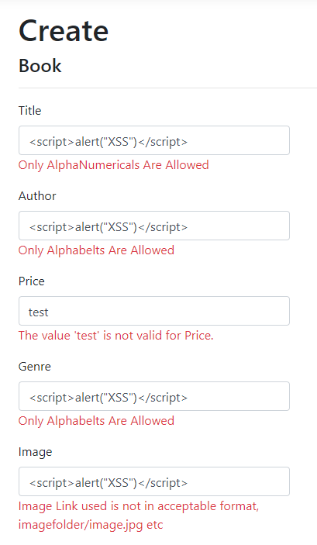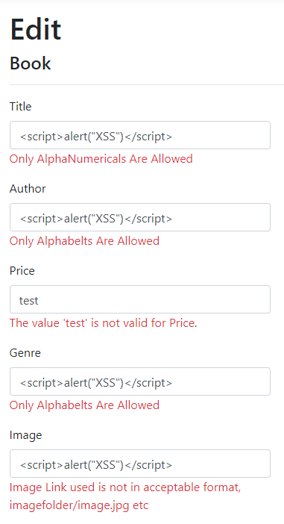

Figure 4.3.1.1.1: Book Create and Edit Input Validation

For the Feedback Page, input validation is implemented in the name, subject, and text input fields, which prevents special characters from being submitted. For the name, the regex only accepts letters while the subject and text only accept letters and some basic punctuation. The code for the regex expression implemented can be seen at Figure 9.5.4.1 and the testing of the regex expressions can be seen below.

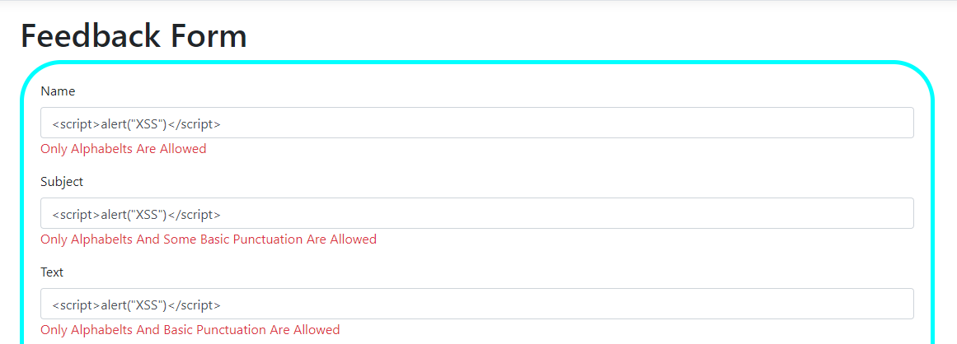

Figure 4.3.1.1.2: Feedback Form Input Validation

For the Roles page, input validation is utilised in the name and description input fields of the create and edit pages. The regex in the name field and the description field only allows letters and simple punctuation marks. The regex expression in the code can be found in figure 3.3.1.1.1 and the results of testing the regex expressions in the roles entry points can be seen in figure 3.3.1.1.3

For the Payment page, all fields of the payment model contain input validation in the form of regular expressions. The code can be seen from 9.5.3.1 and the results of testing the regex expressions in the payment page can be found below.

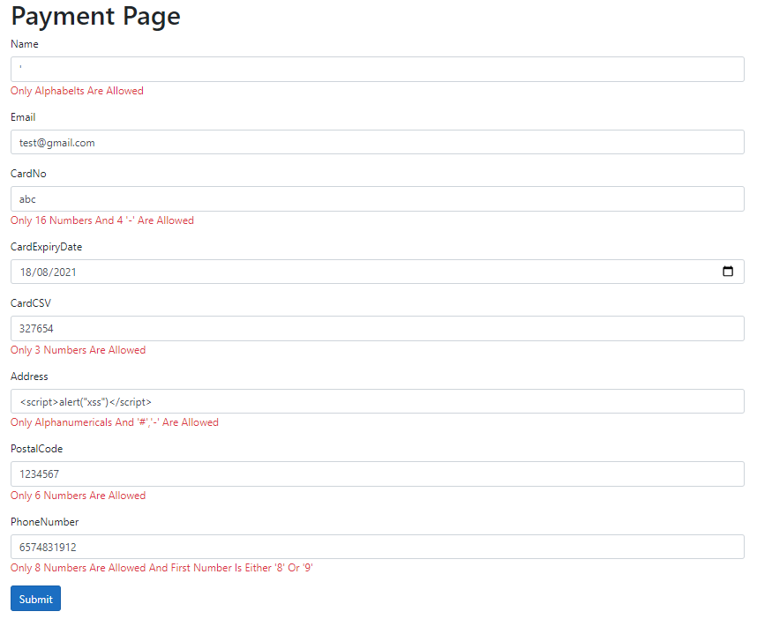

Figure 4.3.1.1.3: Payment Regular Expressions

### 4.3.1.2 Input Sanitisation

Input sanitisation refers to the process of transforming user input into a non-harmful form before being processed by the system. There are three ways input sanitisation can be implemented, which include stripping, substitution and literalisation. Stripping involves removing harmful characters from the data that the user entered. Substitution involves replacing the user input with a harmless copy. Literalisation involves using properties that render the user input to be treated as a literal state.

For example, when a malicious script is taken as input into the audit create page, the input for the audit action and audit subject input fields is taken as its literal form. This way, the malicious script does not execute when the index page is browsed.



Figure 4.3.1.2.1: Audit Input Sanitisation

### 4.3.1.3 Error Handling

When attempting to attack a software, attackers will examine error messages to gain information about the software. Sensitive information may be leaked about the application that may help the attacker perform better and more specific attacks towards the system. In order to prevent leakage of sensitive information, error messages must be relatively vague with only needed information. Detailed error messages produced by the system with stack information and code paths must be abstracted into generic user-friendly error messages.

For the CRUD database, attempting to create an empty book will result in an error. Specific errors with the input that show sensitive information such as code paths are instead made vague and user-friendly.

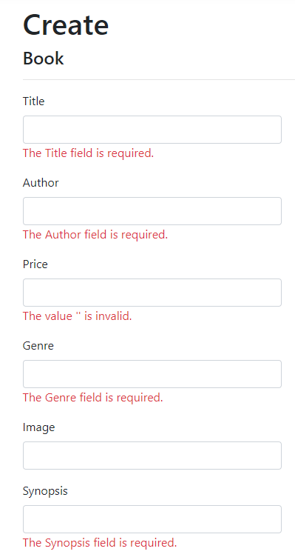

Figure 4.3.1.3.1: Books Create Page Error Handling

## 4.3.2 Secure Software Processes

### 4.3.2.1 Versioning

Versioning is important as it ensures all contributors to the application have the same package versions.

For applications packages pertaining to the application, all members used the same packages with the same package versions. These packages include AntiXss Version 4.3.0, Microsoft.AspNetCore.Authentication.Facebook Version 3.1.15, Microsoft.AspNetCore.Authentication.Google Version 3.1.15, Microsoft.AspNetCore.Authentication.MicrosoftAccount Version 3.1.15, Microsoft.AspNetCore.Identity.EntityFrameworkCore Version 3.1.15, Microsoft.AspNetCore.Identity.UI Version 3.1.15, Microsoft.EntityFrameworkCore.SqlServer Version 3.1.15, Microsoft.EntityFrameworkCore.Tools Version 3.1.15, Microsoft.VisualStudio.Web.CodeGeneration.Design Version 3.1.15, and SendGrid Version 9.24.1.

Bitbucket was also used for collaborative code editing.

### 4.3.2.2 Code Analysis

Visual Studio 2019 provides sufficient code analysis such as errors and warnings to assist in the building of the CRUD database.

### 4.3.2.3 Code/Peer Review

Every member of the group conducted tests and reviewed one another’s code for each feature. Each member had a checklist of items to test for intended behaviour for each feature and tested the security of each feature.

OWASP ZAP, a security tool that can be used to check how secure a software is, was also used to check how secure the website created was.





From the screenshots, the website seems to be quite secure as out of the 4598 processes scanned by the tool, there were only 12 alerts. Hence, our web application has decent security.

# 4.4 Secure Software Testing

Secure software testing refers to testing from an attacker’s point of view to validate the software’s ability to withstand an attack and uncover unintended vulnerabilities that could be exploited. Software tests on the database that have been conducted include testing for input validation, testing for injection flaws controls, testing for scripting attacks controls, testing for non-repudiation controls, testing for error and exception handling controls and testing for privileges escalations controls.

## 4.4.1 Test Strategy

In order to conduct testing on the CRUD database, the resources needed include the databases for Books, Feedback, Roles, Audit and Payment and access to the Admin role in order to have permissions to all operations in each database. The goal of this testing is to determine whether attackers are able to tamper with or steal the data stored in the database through entry points unjustly. The method involves testing each database in order to check if input validation, input sanitisation and error handling are present and functional.

## 4.4.2 Test Plan

|  |  |  |
| --- | --- | --- |
| Test Requirements | Test Methods | Test Coverage |
| Books database | Check for malicious script injection flaw  Check for malicious SQL code injection flaw  Check for scripting attacks | Ensures user supplied input is validated and sanitised before being processed and used to retrieve or modify Books data.  Ensures proper error and exception handling by returning non-verbose error messages. |
| Feedback database | Check for malicious script injection flaw  Check for malicious SQL code injection flaw  Check for scripting attacks | Ensures user supplied input is validated and sanitised before being processed and used to retrieve or modify Feedback data.  Ensures proper error and exception handling by returning non-verbose error messages. |
| Roles database | Check for malicious script injection flaw  Check for malicious SQL code injection flaw  Check for scripting attacks | Ensures user supplied input is validated and sanitised before being processed and used to retrieve or modify Roles data.  Ensures proper error and exception handling by returning non-verbose error messages. |
| Audit database | Check for malicious script injection flaw  Check for malicious SQL code injection flaw  Check for scripting attacks | Ensures user supplied input is validated and sanitised before being processed and used to retrieve or modify Audit data.  Ensures proper error and exception handling by returning non-verbose error messages. |
| Payment database | Check for malicious script injection flaw  Check for malicious SQL code injection flaw  Check for scripting attacks | Ensures user supplied input is validated and sanitised before being processed and used to retrieve or modify Payment data.  Ensures proper error and exception handling by returning non-verbose error messages. |

## 4.4.3 Test Cases

|  |  |  |  |  |
| --- | --- | --- | --- | --- |
| ID | Requirements Specification | Testing Approach | Expected Results | Verdict |
| 1 | Books database  Books Index Page  Admin Role | Input script code such as “<script>alert(“XSS”)</script>” into search filter  Input SQL code into search filter  Input special characters such as <>/\" into search filter | Error message stating “Please Use English Characters Only” | Success |
| 2 | Books database  Books Create and Edit Page  Admin Role | Input script code such as “<script>alert(“XSS”)</script>” into input fields  Input SQL code into input fields  Input special characters such as <>’;:\-. into input fields | Error messages stating “Only Alphabets Are Allowed” or “Only Alphanumerics Are Allowed” | Success |
| 3 | Feedback database  Feedback Create Page  Admin Role | Input script code such as “<script>alert(“XSS”)</script>” into input fields  Input SQL code into input fields  Input special characters such as <>’;:\-. into input fields | Error messages stating “Only Alphabets Are Allowed” or “Only Alphanumerics Are Allowed” | Success |
| 4 | Roles database  Roles Create and Edit Page  Admin Role | Input script code such as “<script>alert(“XSS”)</script>” into input fields  Input SQL code into input fields  Input special characters such as <>’;:\-. into input fields | Error message stating “Only Alphabets And Basic Punctuation Are Allowed” | Success |
| 5 | Audit database  Admin Role | Input script code such as “<script>alert(“XSS”)</script>” into input fields  Input SQL code into input fields  Input special characters into input fields | Input text is taken as its literal and harmless form and is stored in the database | Success |
| 6 | Payment database  Admin Role | Input script code such as “<script>alert(“XSS”)</script>” into input fields  Input SQL code into input fields  Input special characters into input fields | Non-verbose error messages are shown with only the needed information and data is not processed. | Success |

# 4.5 Security Conclusion of the CRUD Database

In conclusion, developing the CRUD database with security in mind is extremely important. The database stores highly sensitive and important information, hence it is vital to take the strictest security precautions and measures when designing a secure database structure. Security features such as input validation, input sanitisation and proper error and exception handling help make the data more secure and mitigates attacks and threats to tamper with the data in the database. Hence, it is crucial to ensure data confidentiality, integrity and availability in the database.

# 5. Miscellaneous Pages

# 5.1 Book Store Page

## 5.1.1 Book Store Page Display

As the team’s focus is on creating an e-commerce book store where people can buy their books online, the first miscellaneous page that needs to be created is the book store itself. For the book store, it was planned to have a total of 4 books displayed per row. Below each book image, the name of the book, price of the book is displayed. A button with the value “Add To Cart!” is also used to add the book chosen to the user’s shopping cart. There is also a link below the button that leads the users to the details of the books.



Figure 5.1.1.1: Book Store Display



Figure 5.1.1.2: Book Details Page Example

Furthermore, a search string and drop down list is used such that users can filter the books. The search string allows for users to filter the books based on the name of the book, and the drop down list allows for users to filter the books based on the books’ genre. The books will only be filtered out when the button with the value, “Filter” is clicked. The link beside the button stating, “cart”, also redirects the user to his cart.

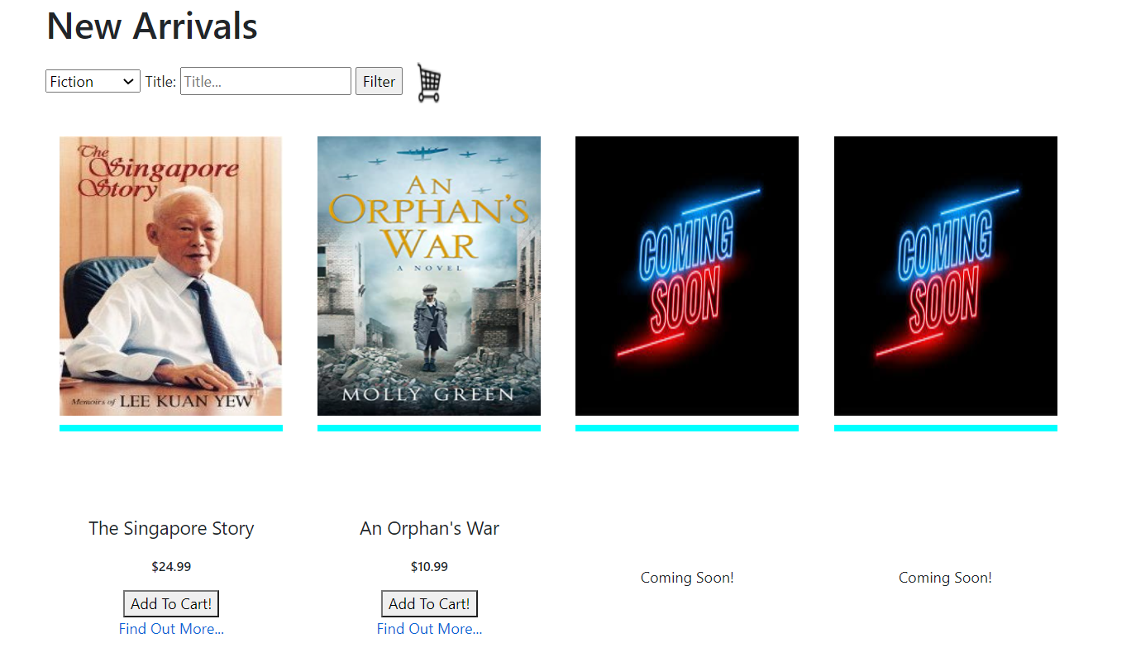

Figure 5.1.1.3: Filtered Books Example

Since each row consists of 4 books, in the event that there are extra spaces left in the row, an image that states “Coming Soon!” will be displayed instead. The words, “Coming Soon!” will also be shown below the image.

In the event the creator of the object adds in a wrong image path, or a path that cannot be located by the program, an image that shows “Image Not Available” will be used instead.

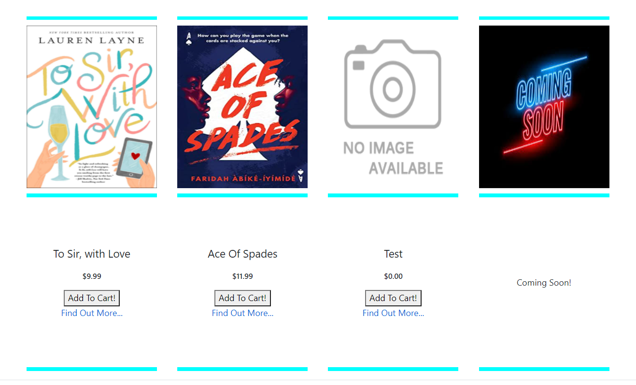

Figure 5.1.1.4: No Image Example

## 5.1.2 Book Store Page Code

### 5.1.2.1 Book Object Class

Firstly, the book object class had to be created. A total of 7 items were used in the class. The first item is an ID, which is used as a primary key. The second item is the title of the book, the third is the author of the book, the fourth is price of the book, the fifth is the image path of the book, the sixth is the genre of the book, and the last is the synopsis of the book

### 5.1.2.2 Book Object Class Input Validation

For the book object validation, regex expressions were used to ensure the data inputted when creating a book is in a non-malicious format. For the title of the book, the english alphabets, numbers and some basic punctuation such as “ ‘!?_” are allowed. For the Author of the book, the characters allowed are the english alphabets and “-”. For the price of the books, the data type is set to be in currency and thus whatever that is inputted must be in the same format as a currency. For the Image path, english alphabets, numbers and punctuations such as “/._” are allowed. For the genre of the book, only alphabets and spaces are allowed. There were no regex expressions for synopsis as a synopsis of a book may contain all the punctuations and special characters. All of these items also have the [Required] tag and thus a null value cannot be submitted. Figure 5.1.2.1.1 shows the regex expressions used in the class.

### 5.1.2.3 Book Store Code

The first code used was to check to see if the user accessing the page belongs to the role of either “Admin” or “BookAdmin”. If the user is, then a link with the value “Create New” will be shown. This code is used so as to hide administrative links from customers to ensure that they do not have any attempt to go to administrative pages.

The next part of the code is the code used for displaying the search string and drop down list. The drop down list searches for all the genres in the database and displays all the genres found. The search string is an input with type set to text. Furthermore, there are input validations set for the search string. A maximum input length of 30 characters has been set, and also the search string has a restriction of a few characters such as “<>//.

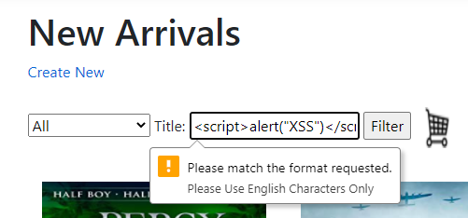

Figure 5.1.2.3.1: Example of Input validation In Effect

The next part of the code is to check to see if there are any books present in the database or to check to see if there were any books that were filtered out. If there were none, an error message stating that no books were found will be displayed.

Moving on to the bulk of the code, where the books images are displayed. The code first searches for the number of books in the database. Then, a loop is used to loop through the books. For every four counts in the loop, four columns will be created and four book images will then be displayed in each column. Using a counter in the loop, the image belonging to the book will be extracted from the database. A table is created in each column and the code will again use the counter to retrieve information regarding the title and name from the database. A button which uses a few javascript functions to submit the item to the cart is also added, and a link that is used to redirect to the details page is added. The code uses the counter and deduces the book’s ID. Using the ID, the code will then display the full details associated with the ID.

In the event the number of books in the database is not a multiple of four, there will be a remaining number of books in the last row. In order to fill up the missing book items to ensure that each row has four items, a “coming soon” item will be used. A “coming soon” item is an image showing, “Coming Soon!” and the text value will display “coming soon” as well. It was decided not to be left blank, because it can give negative impressions on customers that the books available are very limited. Thus, this “coming soon” item will give the impression that there is more to come. This remainder is calculated by the program and based on the value of this remainder, the number of “coming soon items” is determined and inputted into the program.

# 5.2 Cart Page

## 5.2.1 Cart Page Display

When users want to order multiple books at once, a shopping cart is needed for users to easily hold their books before checking out. When browsing books in the books index page, users can access the cart page by clicking the shopping cart icon at the top of the index page next to the search filter. When users decide to add an item to the cart, an alert will pop up confirming that they have added the item to their cart and stating the price of the item. When users do access the cart page, users will be able to view items that they have put in their cart. When users are satisfied with their cart, they can press the checkout button and they will be redirected to the payment page to complete their payment. If the user has not chosen any items and the cart is empty, the cart page will display bold text informing the user that their cart is empty and does not allow them to check out with an empty cart.

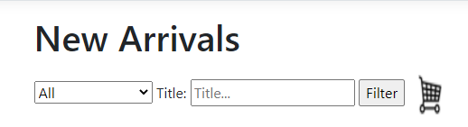

Figure 5.2.1.1 Cart Icon in Books Index Page

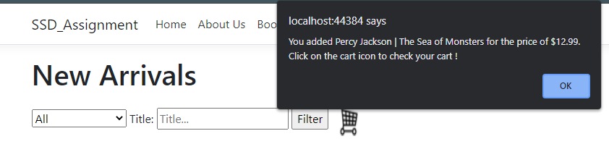

Figure 5.2.1.2 Adding an Item to Cart

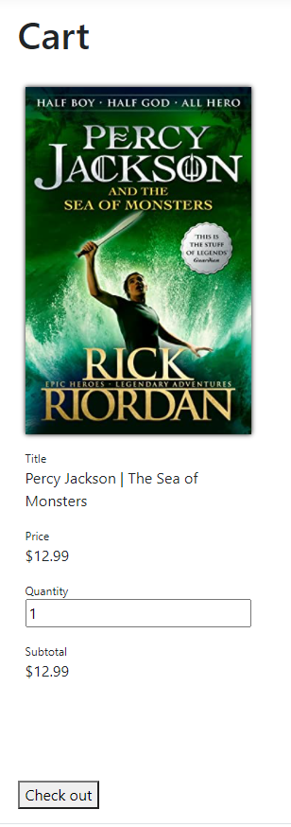

Figure 5.2.1.3 Cart Page



Figure 5.2.1.3 Cart Page with Empty Cart

## 5.2.2 Cart Page Code

### 5.2.2.1 Cart Code

When users add items to their cart, the information about the items will be added to a cart array. When the user clicks the cart icon and heads to the cart page, the cart array is converted into a JSON format and stored in the window session storage. The cart page is then able to access the cart in JSON form in the session storage and displays the items stored in the cart onto the cart page. Each item in the cart contains information including the title, price and the source of the image. For each item, a cart displays the book cover image, title, price of the book, quantity and subtotal. A checkout button is added to the bottom of the cart page which will redirect the user to the payment page.

# 5.3 Payment Page

## 5.3.1 Payment Page Display

Payment Page is a page full of input fields that is related to the payment details of the user. Users must enter all of the fields in order to submit the payment page. The items the user inputted in will be saved in the database. If form submission is successful, the user will be redirected to a successful payment page.

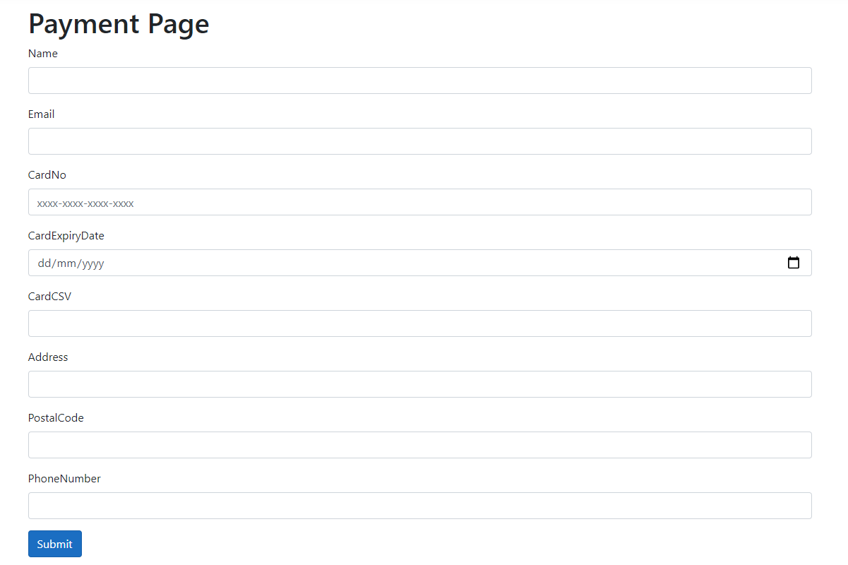

Figure 5.3.1.1: Payment Page Display

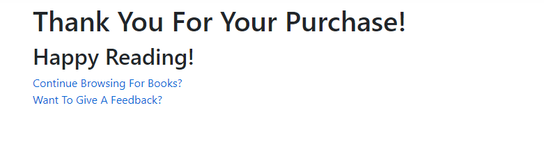

Figure 5.3.1.2: Payment Thank You Page Display

## 5.3.2 Payment Page Code

### 5.3.2.1 Payment Page Class

For the payment page class, there are a total of nine items. The first item is the ID of the payment, which is used as the primary key in the database. The second item is the name of the user. The third item is the email of the user. The fourth item is the credit card number. The fifth item is the credit card expiry date. The sixth item is the CSV value of the credit card. The seventh item is the Billing address of the user. The eighth item is the postal code. The last item is the phone number of the user.

### 5.3.2.2 Payment Page Class Input Validation

For the input validation used for the input fields of the payment, regex expressions were used in the class. For the name of the user, the regex expression allows for the user to only use english alphabets and a space as valid input. For the email of the user, the english alphabets, numbers, and some basic punctuation such as “@_” is allowed. For the card number, only numbers and ‘-’ are allowed. For the card expiry date, the data type is set to be date and so only date inputs are allowed. Furthermore, a javascript was used in the payment page to set the minimum date of the expiry date to be set to the date today. This ensures that users cannot enter a date earlier than today. For the CSV value, only three digits are allowed. For the billing address, both the english alphabets, numbers and some punctuations are allowed such as “-”,”#”. For the postal code, only six digits are allowed for input. Lastly, for the phone number, only 8 digits are allowed, with the first being a 8 or 9. All of this also has the [Required] tag and thus users cannot submit null values.

### 5.3.2.3 Payment Page code

The payment page is a form. The contents of the form consists of nine items, each representing an item in the class. For each item, a label tag is used to extract the item name from the class and to display it in the form. An input tag is used to get the user's input. Lastly, a span tag is used to display error messages if any. There is also a button with the value “submit” that submits the form. This button will also redirect the user to a payment successful page

### 5.3.2.4 Payment Successful Page code

The payment successful page consists of only a few items. It first consists of header items that thank the user for his purchase. Then it consists of two links, one link to redirect back the user to the bookstore shop, and the second is to redirect the user to a feedback form.

# 5.4 Feedback Form

## 5.4.1 Feedback Form Display

The feedback form consists of three inputs that are required. This feedback form allows users to communicate with the team of the website so as to point out any compliments, mistakes, errors or suggestions. The feedback will also be stored in the database. After submitting the feedback, the user will be redirected to a “thank you” page.

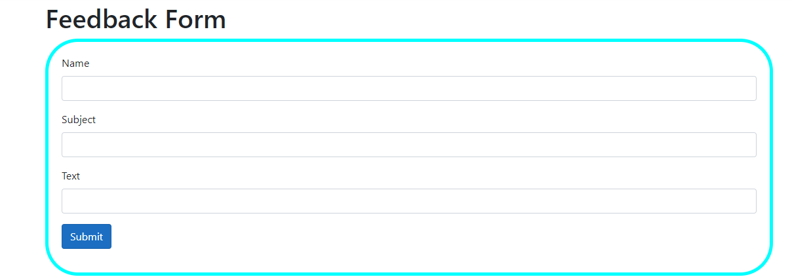

Figure 5.4.1.1 : Feedback Form Display

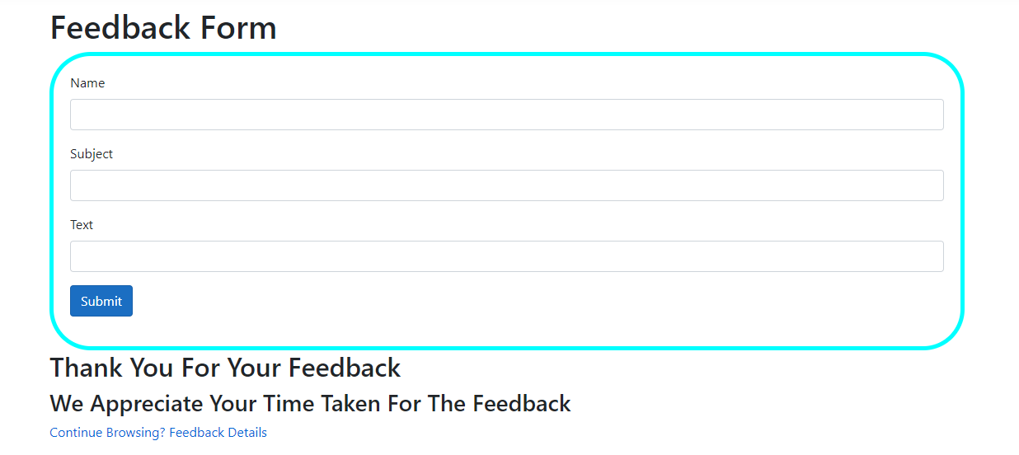

Figure 5.4.1.2: Feedback Thank You Page Display

If the user on the feedback form page belongs to “Admin”, or “FeedbackAdmin”, the user will see a link at the bottom of the page which allows the user to view the feedback .

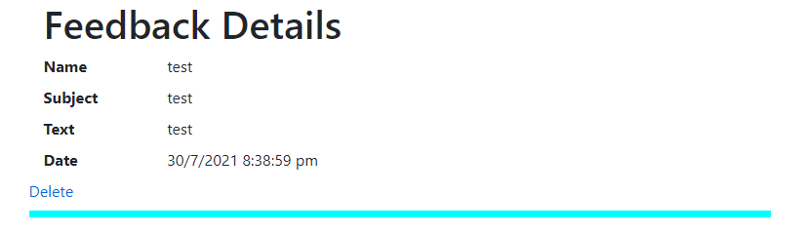

Figure 5.4.1.3: Feedback Details Page Display

## 5.4.2 Feedback Form Code

### 5.4.2.1 Feedback Object Class

The feedback object class has five items. The first is the ID of the feedback, which will be used as the primary key in the database. The second is the name of the user. The third is the name of the subject for the feedback. The fourth is the text that is to be inputted in the feedback and the last is the date and time the feedback is created.

### 5.4.2.2 Feedback Object Validation

The validation used for the input in the feedback page is coded in by using regex expressions. When the user enters the name, only english alphabets and a space is allowed to be entered. For entering the subject of the feedback, only english alphabets and some basic punctuations such as “!,?” are allowed. For entering the text of the feedback, only english alphabets and basic punctuation are available for the user to use. These three items also have the [Required] tag and thus users cannot submit a null value.

### 5.4.2.3 Feedback Form Page

Similar to the payment page, the feedback form page is a form. The contents of the form consists of three items, each representing an item in the class. For each item, a label tag is used to extract the item name from the Feedback class and to display it in the form. An input tag is used to get the user's input. Lastly, a span tag is used to display error messages if any. There is also a button with the value “submit” that submits the form. This button will also redirect the user to another page to thank them. Furthermore, the code also checks to see if the current user belongs to the role,”Admin” or “Feedback Admin”. If the user does belong to either role, a link will be displayed for them to access the list of feedback made. If the user does not belong to either role, the link will not be there.

### 5.4.2.4 Feedback Thank You Page

The Feedback Thank You Page is an exact replica of the feedback page. However, the only change is that there will be two headers and an extra link. The two headers will thank the user for taking the time to submit the feedback and the link will redirect the user to the book store page.

# 6 Advanced Authentication Features

## 6.1 Email Confirmation and Forgot Password Email

We first installed the SendGrid NuGet Package version 9.24 and Configured a Sender as well as an API Key after registering for an account.

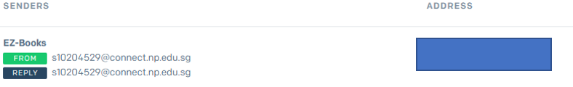

Figure 6.1.1 : SendGrid Sender

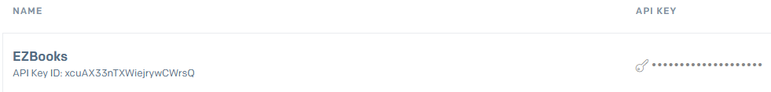

Figure 6.1.1 : SendGrid API Key

Next, I configured the secret users, EZBooks and SendGridKey

Figure 6.1.2 Secret-Users SendGridKey & SendGridUser

Then, I created added AuthMessageSenderOptions.cs and EmailSender.cs into Pages\Services

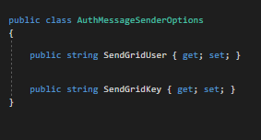

Figure 6.1.3 : AuthMessageSenderOptions

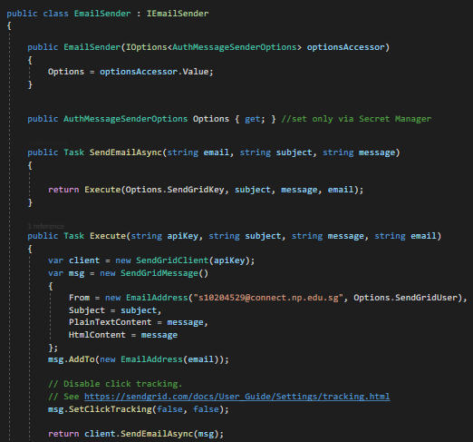

Figure 6.1.4 : EmailSender.cs

The Class takes the user-secrets api key and sendgrid user and sends an email using the Execute() function. Next, I commented out section of code in RegisterConfirmation.cshtml.cs for the sendgrid function to work

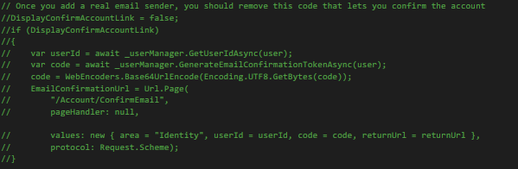

Figure 6.1.5 : Commented code.



Figure 6.1.6 : Confirmation Email via SendGrid

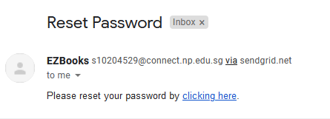

Figure 6.1.7 : Reset Password email via SendGrid

## 6.2 QR CodeMulti-factor Authentication

Downloaded QR code from GitHub, named it qrcode and added it into wwwroot\lib

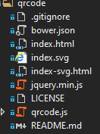

Figure 6.2.1 : qrcode file

Then, I changed the file directory to the qr code file path in EnableAuthenticator.cshtml and this is how the multi-factor authentication page will look after adding the qr code

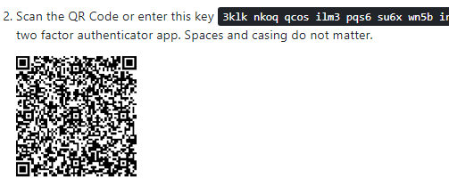

Figure 6.2.2 : Razor Pages Enable Authenticator

## 6.3 External Login

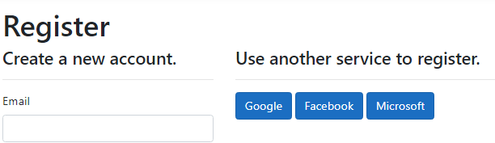

Figure 6.3.1 : External Login Icons

The external login feature allows users to register an account without the need of creating one using the entry points in the web application. Once the user has registered via one of the external platforms, they need to press the external platform used and will be immediately signed in into the web application.

### 6.3.1 Google External Login

For Google External Login, I download the Microsoft.AspNetCore.Authentication.Google Package made credentials as well as a OAuth Consent Screen.

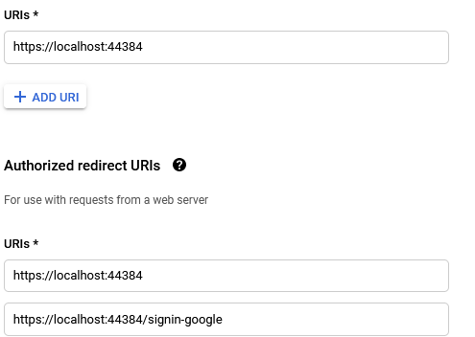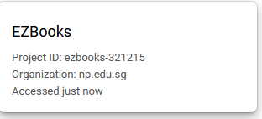

Figure 6.3.1 : Credentials Creation and OAuth Consent SCreen

Next, I Added the google client id and client secret key to my user secrets



Figure 6.3.2: Adding Google Client ID And Secret Key

Lastly, I Added the google external login code to my Startup.cs page

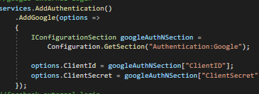

Figure 6.3.3: Adding Google External Login

### 6.3.2 Facebook External Login

For Facebook External Login, I first downloaded the Microsoft.AspNetCore.Authentication.Facebook Nuget Package.

Then, I created a Facebook developer account where I entered my App

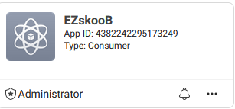

Figure 6.3.2.1 : Facebook App Creation

Then, I Entered a valid redirect url and got my API Key and APP ID and added it to my user secrets as well as entering the external login code to my startup.cs



Figure 6.3.2.1: Adding Facebook ClientID And SecretKey

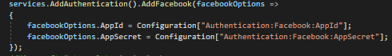

Figure 6.3.2.2: Adding Facebook External Login

### 6.3.3 Microsoft External login

For Microsoft External Login, I first downloaded the Microsoft.AspNetCore.Authentication.MicrosoftAccount Nuget Package and Registered an Azure Account.

Next, I created an app registration and similarly, added the localhost urls.

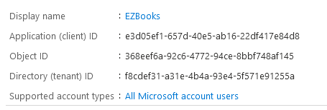

Figure 6.3.3.1: Creating App Registration

I then created a new client secret and stored the client id and api key in my user secrets and added the external login code in my startup cs



Figure 6.3.3.2: Adding Microsoft ClientID And SecretKey

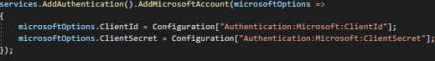

Figure 6.3.3.3: Adding Microsoft External Login

# 7. Conclusion

In conclusion, secure software is very important in an application. In order to make an application secure it consists of a series of requirements as explained in this report. These requirements such as Authentication and Authorization must work closely together in order to ensure that the software is secure. If any of the requirements are missing or lacking, attackers will be able to attack the website and that can have an impact on everything. Security features such as input validation, sanitisation, error and exception handling also help in mitigating attacks towards the database. Many disastrous outcomes could occur such as stealing of personal information and data loss can occur if the software is not secure. Although security features do not help the company in gaining money and making profits, it helps the company to drastically reduce costs of system damage by preventing attacks and thus it is important to incorporate security into the software development life cycle. As seen from this assignment, designing with security in mind, helps businesses and is a good mentality to have.

# 8 References

# 8.1 Authentication References

Anderson, R., Ponant, & Audette, J. (2019, 3 11). *Account confirmation and password recovery in ASP.NET Core.* Retrieved from Microsoft: <https://docs.microsoft.com/en-us/aspnet/core/security/authentication/accconfirm?view=aspnetcore-5.0&tabs=visual-studio>

Cloudflare. (n.d.). *Application layer DDoS attack.* Retrieved from Cloudflare: <https://www.cloudflare.com/learning/ddos/application-layer-ddos-attack/>

Lisk. (2018, August 8). *What is Hashing? Hash Functions Explained Simply* [Video]. Youtube. https://www.youtube.com/watch?v=2BldESGZKB8

Muller, N. (n.d.). *Credential stuffing.* Retrieved from OWASP: https://owasp.org/www-community/attacks/Credential_stuffing#

Novytskyy, V., & Anderson, R. (2020, 23 1). *Facebook, Google, and external provider authentication in ASP.NET Core.* Retrieved from Microsoft: <https://docs.microsoft.com/en-us/aspnet/core/security/authentication/social/?view=aspnetcore-3.1&tabs=visual-studio>

OStack Development Team. (n.d.). *Security/OSSA-Metrics*. Retrieved from OStack: <https://wiki.openstack.org/wiki/Security/OSSA-Metrics#Scoring_does_not_replace_experience>

Schneier, B. (1999, December). *Section 1.3. An Alternative: Attack Trees.* Retrieved from eTutorials: http://etutorials.org/Linux+systems/secure+linux-based+servers/Chapter+1.+Threat+Modeling+and+Risk+Management/Section+1.3.+An+Alternative+Attack+Trees/

Shim, D. (2018, 8 14). *Enable QR Code generation for TOTP authenticator apps in ASP.NET Core.* Retrieved from Microsoft: <https://docs.microsoft.com/en-us/aspnet/core/security/authentication/identity-enable-qrcodes?view=aspnetcore-5.0>

# 8.2 Authorization References

HowtoASP.Net. (2021, July 31). *How to handle and display user input to protect ASP.NET web application from XSS in C#*. Retrieved from HowToASP: https://www.howtoasp.net/how-to-handle-and-display-user-input-to-protect-asp-net-web-application-from-xss-in-c/

LogixConsulting. (2019, December 18). *What Is the DREAD Cybersecurity Model?* Retrieved from Logix: https://www.logixconsulting.com/2019/12/18/what-is-the-dread-cybersecurity-model/

Microsoft. (2011, January 12). *Adding Validation to the Model (C#)*. Retrieved from Microsoft: https://docs.microsoft.com/en-us/aspnet/mvc/overview/older-versions/getting-started-with-aspnet-mvc3/cs/adding-validation-to-the-model

Microsoft. (2019, 10 23). *ASP.NET Security: An Introductory Guide to Building and Deploying More Secure Sites with ASP.NET and IIS*. Retrieved from microsoft.com: https://docs.microsoft.com/en-us/archive/msdn-magazine/2002/april/asp-net-security-an-introductory-guide-to-building-and-deploying-more-secure-sites-with-asp-net-and-iis

Microsoft. (2020, September 1). *Overview of source code analysis*. Retrieved from Microsoft: https://docs.microsoft.com/en-us/visualstudio/code-quality/roslyn-analyzers-overview?view=vs-2019

Microsoft. (2021, February 2). *Regular Expression Language - Quick Reference*. Retrieved from Microsoft: <https://docs.microsoft.com/en-us/dotnet/standard/base-types/regular-expression-language-quick-reference>

OStack Development Team. (n.d.). *Security/OSSA-Metrics*. Retrieved from OStack: <https://wiki.openstack.org/wiki/Security/OSSA-Metrics#Scoring_does_not_replace_experience>

PaloaltaNetwork. (n.d.). *What is a denial of service attack (DoS) ?* Retrieved from PaloaltaNetwork: https://www.paloaltonetworks.com/cyberpedia/what-is-a-denial-of-service-attack-dos#:~:text=A%20Denial%2Dof%2DService%20(,information%20that%20triggers%20a%20crash.

TheEconomicTimes. (2021, July 31). *Definition of 'Authorization'*. Retrieved from TheEconomicTimes: https://economictimes.indiatimes.com/definition/authorization

# 8.3 CRUD Database References

ALTVATER, A. (2017, May 2). *What are CRUD Operations: How CRUD*

*Operations Work, Examples, Tutorials & More*. Retrieved from Stackify:

https://stackify.com/what-are-crud-operations/

codecademy. (n.d.). *What is CRUD?* Retrieved from codecademy: https://www.codecademy.com/articles/what-is-crud

EduardoFernández-Medina. (2005, May 15). *Designing secure databases*. Retrieved from ScienceDirect: https://www.sciencedirect.com/science/article/abs/pii/S0950584904001429

Microsoft. (2021, January 5). *Part 4 of tutorial series on Razor Pages*. Retrieved from Micrososft: https://docs.microsoft.com/en-us/aspnet/core/tutorials/razor-pages/sql?view=aspnetcore-3.1&tabs=visual-studio

sumo logic. (n.d.). *CRUD*. Retrieved from sumo logic: https://www.sumologic.com/glossary/crud/

# 8.4 Code References

Dev, S. W. (2018, October 5). *JavaScript Shopping Cart Tutorial for Beginners*. Retrieved from Youtube: https://www.youtube.com/watch?v=YeFzkC2awTM

GeeksForGeeks. (2021, July 2). *What is Regular Expression in C#?* Retrieved from GeeksForGeeks: https://www.geeksforgeeks.org/what-is-regular-expression-in-c-sharp/#:~:text=In%20C%23%2C%20Regular%20Expression%20is,that%20allows%20the%20pattern%20matching.

goodreads. (n.d.). *Ace of Spades*. Retrieved from goodreads: https://www.goodreads.com/book/show/42603984-ace-of-spades?from_search=true&from_srp=true&qid=NmliDHW7Ux&rank=1

goodreads. (n.d.). *An Orphan’s War*. Retrieved from goodreads: https://www.goodreads.com/book/show/45449366-an-orphan-s-war

goodreads. (n.d.). *Percy Jackson and the Lightning Thief*. Retrieved from goodreads: https://www.goodreads.com/book/show/51877287-percy-jackson-and-the-lightning-thief

goodreads. (n.d.). *The Battle of the Labyrinth*. Retrieved from goodreads: https://www.goodreads.com/book/show/51876126-the-battle-of-the-labyrinth

goodreads. (n.d.). *The Last Olympian*. Retrieved from goodreads: https://www.goodreads.com/book/show/51876749-the-last-olympian

goodreads. (n.d.). *The Sea of Monsters*. Retrieved from goodreads: https://www.goodreads.com/book/show/51877697-the-sea-of-monsters

goodreads. (n.d.). *The Singapore Story: Memoirs of Lee Kuan Yew*. Retrieved from goodreads: https://www.goodreads.com/book/show/326981.The_Singapore_Story

goodreads. (n.d.). *The Titan's Curse*. Retrieved from goodreads: https://www.goodreads.com/book/show/51875613-the-titan-s-curse

Microsoft. (2016, October 14). *Role-based authorization in ASP.NET Core*. Retrieved from Microsoft: https://docs.microsoft.com/en-us/aspnet/core/security/authorization/roles?view=aspnetcore-5.0

Microsoft. (2021, February 2). *Regular Expression Language - Quick Reference*. Retrieved from Microsoft: https://docs.microsoft.com/en-us/dotnet/standard/base-types/regular-expression-language-quick-reference

Microsoft. (n.d.). *Roles.IsUserInRole Method*. Retrieved from Microsoft: <https://docs.microsoft.com/en-us/dotnet/api/system.web.security.roles.isuserinrole?view=netframework-4.8>

W3Schools. (n.d.). *HTML onerror Event Attribute*. Retrieved from W3Schools:

https://www.w3schools.com/tags/ev_onerror.asp

# 9. Appendix

# 9.1 CheckList Of Authentication

|  |  |
| --- | --- |
| Part | Progress |
| Introduction About Authentication | ✅ |
| Explanation Authentication as a Secure Software Requirement | ✅ |
| Data Classification | ✅ |
| Subject-Object Matrix | ✅ |
| Use and Misuse Cases | ✅ |
| Explanation of Secure Software Design | ✅ |
| Features Related To Authentication | ✅ |
| Entry and Exit Points | ✅ |
| Attack Trees | ✅ |
| STRIDE Model | ✅ |
| Explanation of STRIDE Model | ✅ |
| DREADi | ✅ |
| Input Validation | ✅ |
| Input Sanitization | ✅ |
| Error Handling | ✅ |
| Versioning | ✅ |
| Code Analysis | ✅ |
| Code/Peer Review | ✅ |
| Secure Software Testing Explanation | ✅ |
| Test Strategy | ✅ |
| Test Plan | ✅ |
| Test Cases | ✅ |
| Authentication Conclusion | ✅ |

# 9.2 CheckList of Authorization

|  |  |
| --- | --- |
| Part | Progress |
| Introduction About Authorization | ✅ |
| Explanation Authorization as a Secure Software Requirement | ✅ |
| Data Classification | ✅ |
| Subject-Object Matrix | ✅ |
| Use Cases | ✅ |
| Misuse Cases | ✅ |
| Explanation of Secure Software Design | ✅ |
| Features Related To Authorization | ✅ |
| Entry Points | ✅ |
| Exit Points | ✅ |
| Attack Trees | ✅ |
| STRIDE Model | ✅ |
| Explanation of STRIDE Model | ✅ |
| DREADi | ✅ |
| Input Validation | ✅ |
| Input Sanitization | ✅ |
| Error Handling | ✅ |
| Proper Role Management | ✅ |
| Versioning | ✅ |
| Code Analysis | ✅ |
| Code/Peer Review | ✅ |
| Secure Software Testing Explanation | ✅ |
| Test Strategy | ✅ |
| Test Plan | ✅ |
| Test Cases | ✅ |
| Authorization Conclusion | ✅ |

# 9.3 CheckList of CRUD Database

|  |  |
| --- | --- |
| Part | Progress |
| Introduction About CRUD Database | ✅ |
| Explanation CRUD Database as a Secure Software Requirement | ✅ |
| Use Cases & Misuse Cases | ✅ |
| Data Classification | ✅ |
| Subject-Object Matrix | ✅ |
| Explanation of Secure Software Design | ✅ |
| Features Related To CRUD Database | ✅ |
| Entry Points | ✅ |
| Exit Points | ✅ |
| Attack Trees | ✅ |
| STRIDE Model | ✅ |
| Explanation of STRIDE Model | ✅ |
| DREAD risk assessment | ✅ |
| Input Validation | ✅ |
| Input Sanitization | ✅ |
| Error Handling | ✅ |
| Versioning | ✅ |
| Code Analysis | ✅ |
| Code/Peer Review | ✅ |
| Secure Software Testing Explanation | ✅ |
| Test Strategy | ✅ |
| Test Plan | ✅ |
| Test Cases | ✅ |
| CRUD Database Conclusion | ✅ |

# 9.4 CheckList of Code

|  |  |
| --- | --- |
| Part | Progress |
| CRUD Database | ✅ |
| Authentication Feature | ✅ |
| External Log In Features | ✅ |
| Authorization Feature (Roles Class) | ✅ |
| Authorization Management (Managing Accounts To Roles) | ✅ |
| Authorization Implementation (Implementing Authorization In Code) | ✅ |
| Audit Feature (Audit Class) | ✅ |
| Audit Implementation (Implementing Audit In Code) | ✅ |
| Books Pages | ✅ |
| Books Object Seeded | ✅ |
| Cart Page | ✅ |
| Payment Pages | ✅ |
| Feedback Pages | ✅ |
| Input Validation | ✅ |
| Error Handling | ✅ |
| Testing | ✅ |

# 9.5 Code Used For Miscellaneous Pages

## 9.5.1 Code For Book Pages

### 9.5.1.1 Code Used For Book Pages

### 9.5.1.2 Code Used For Checking Authorization

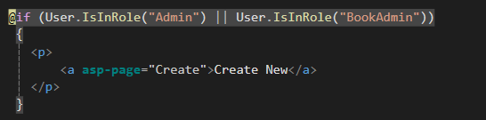

### 9.5.1.3 Code Used For Searchstring And Drop Down List

### 9.5.1.4 Code Used To Display Error Message When 0 books Are In The Database

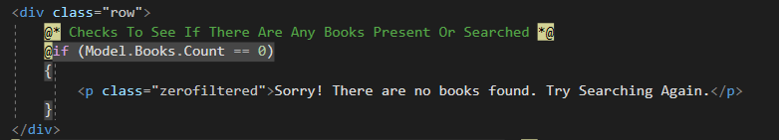

### 9.5.1.5 Code Used For Displaying Book Items

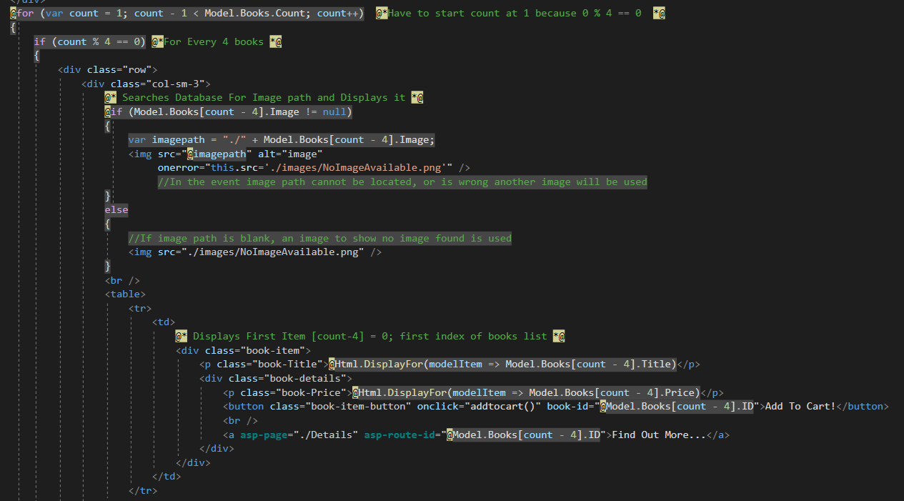

### 9.5.1.6 Code used For Displaying Last Row Contents

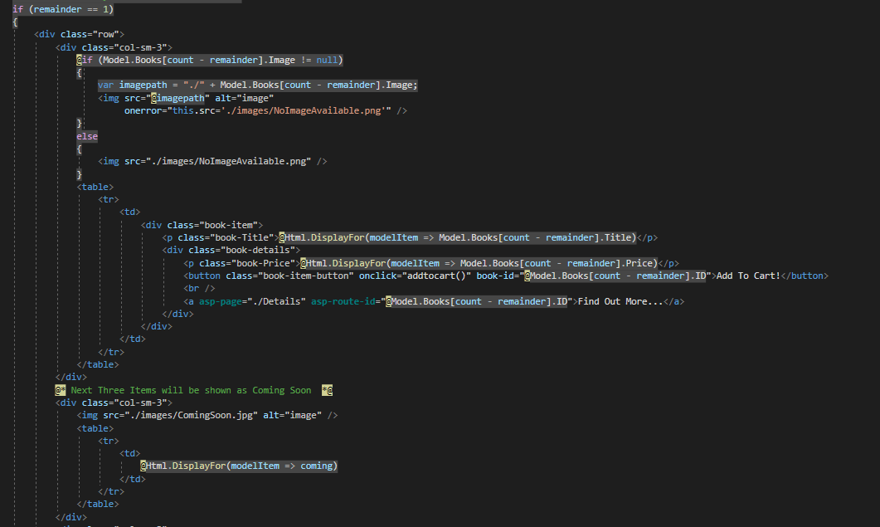

## 9.5.2 Code Used For Cart page

### 9.5.2.1 Code Used for Displaying Cart Page

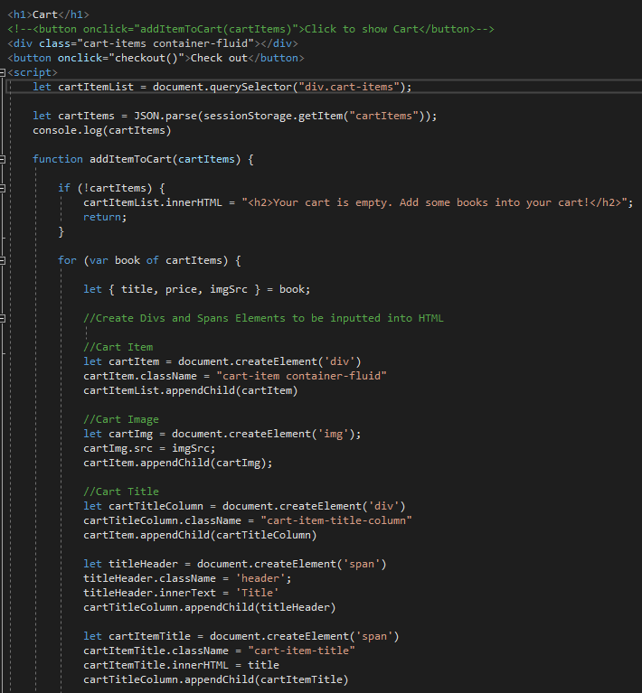

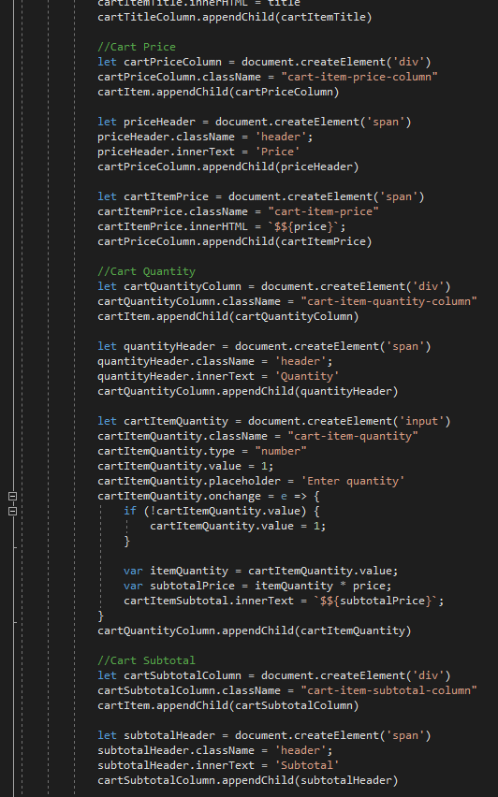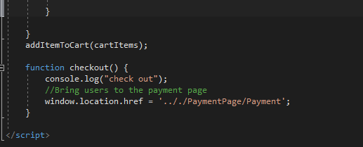

## 9.5.3 Code Used For Payment page

### 9.5.3.1 Code Used For Payment Class

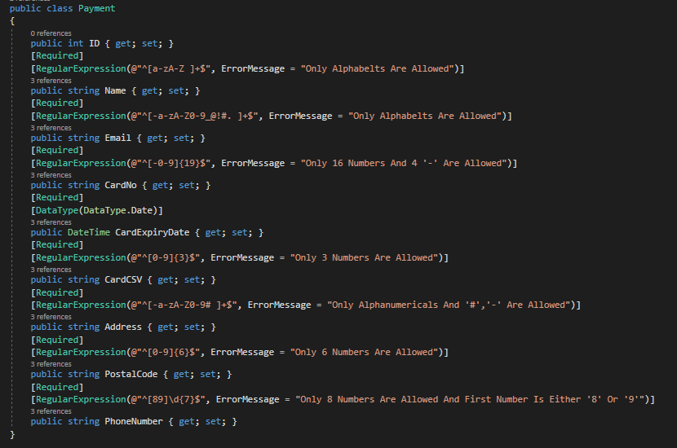

### 9.5.3.2 Code Used Displaying Payment Page

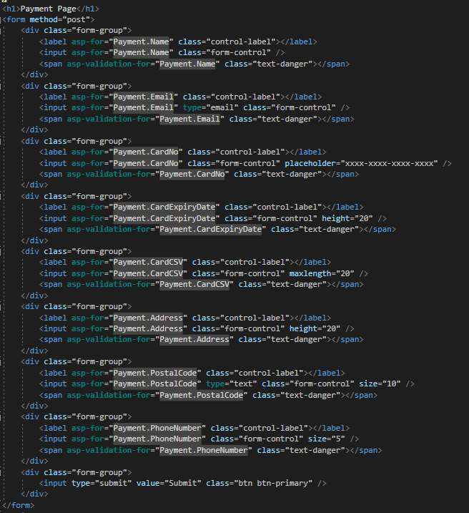

### 9.5.3.3 Code For Displaying Thank You Page

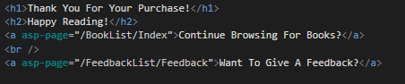

## 9.5.4 Code Used For Feedback page

### 9.5.4.1 Code Used For Feedback Class

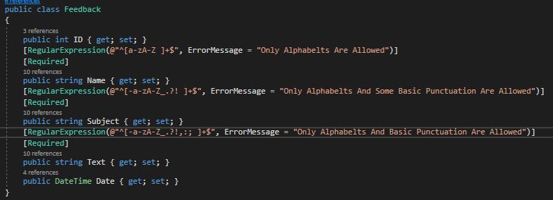

### 9.5.4.2 Code Used For Displaying Feedback Form Page

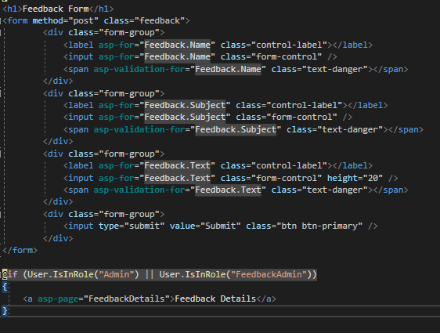

9.5.4.3 Code Used For Displaying Feedback Thank You Page



 